|  |  |  |
| --- | --- | --- |
| Final Year Project Report | **Donal Maher BSc LM080 09007388 Supervisor: Dr Michael Connelly** | |
| The strain of the length of steel when applying an external force is measured by a set of foil strain gauges connected in a Wheatstone configuration making a full bridge .When there is load suspended on the end of the test specimen the strain on the metal was measured using a full bridge foil strain gauge system, all of the measurements were processed, amplified and graphically displayed in real time in LabView. A measured results from a strain gauge systems were compared with calculated theoretical strain at two specific points from which it was observed that system one is 94% accurate when compared to ideal strain results. When strain was measured over changing temperature it was observed that system one is ±0.04 µs and system two is ±0.14 µs accurate per degree Celsius change in temperature. | | Title: Strain gauge LabView based strain gauge measurement system. |

**Contents**

Part 1: Overview

1. Introduction
2. Project Title
3. Project Aims
4. Block Diagram

Part 2: Objective

2.1 Aim of the project

2.2 Structure of the report

Part 3: Theory

3.1Theory Foil strain gauge

3.2 The theory of the foil strain gauge

3.3 Canter viler theory

3.4 Temperature effect

3.4 Amplifier theory

3.5 Software theory

3.6 DAQ theory

3.7 History of the strain gauge

3.8 Application of the strain gauge

Part 4: Procedure

3.1 Introduction 10

3.2 Sensors 10

3.2.1 Foil Strain Gauges Sensor 10

3.2.2 Temperature Sensor 11

3.4 Potential Errors and Solutions 12

3.4.1 Foil Strain Gauge Sensor 12

3.4.2 Temperature Sensor 13

3.5 Sensor Measuring Circuit Configuration 13

3.5.1 Wheatstone bridge Configuration 13

3.5.2 Testing Wheatstone bridge configuration 14

3.5.3 Voltage Potential Divider Configuration 16

3.5.4 Testing Potential Divider Configuration 16

3.6 Consideration 17

3.6.1 Wiring 17

3.6.2 Mounting Strain Gauge 18

3.7 Sensor Placement 18

3.8 Conclusion 19

Hardware Implementation 20

Part 5: Discussion

1. Option 1
2. Option 2
3. Voltage Divider

Part 6: Results

6.1 Strain Measurement

6.1 Amplifying the Stain Measurement

6.2 PCB Amplifier

Part 7: ADC Converter

7.1 Conversion to Analogy to digital

7.2 ADC Block diagram

Part 8: LabVIEW

8.1 Graphical Programming

8.2 Basic Program

Part 9 Discussion

Part 10 conclusions

Part 11: Bibliography

Part 1: Introduction and Project Outline

1.1 Introduction

This project involves both hardware and software, which is the outline for LM080. In this interim report the reader will be informed on the procedure for the proposed project, building of the hardware and software components that will fulfil the brief. As we move forward, we strive to go faster, build higher while using the minimum material required completing the designs. We look at pushing the bounds of construction designing to lower tolerances and less material. This project designed and built here could be used in many applications balancing between safety and economics is very important factor in designing a structure. To design structure which ensures required safety regulations are met, while keeping in balance with the budget, it is important to know the stress experienced by each material part. This is where the strain gauge comes in, this project highlight the importance of showing the amount of strain a material is under. When designing new automobiles, trains and planes, the structure shell is designed to be lighter to consume less fuel consumption. It is possible to design a lighter and more efficient product by selecting lighter materials and making them thinner for use. If only the strength of the product is taken into consideration, the weight of the product increases and the economic feasibility is impaired.

However, at present scientific level there is no technology available which enables direct measurement and judgment of stress. Because of that the strain on the surface of test specimen is measured in order to know the internal stress. Strain gauges are the most common sensing element up to data used for measuring strain. **[1]**

1.2 Project Title

Strain gauge LabView based strain gauge measurement system.

Using four foil stain gauges to measure the strain on a length of steel while external force is applied.

This project will use

* 1. four foil strain gauges
  2. RS Amplifier
  3. Thermocouple/ thermistor
  4. Signal acquisition using an NI USB-6008 A/D acquisition card.
  5. Signal processing using LabView including real-time display of the strain and temperature.

1.2 Project Aims

This project will be used to measure the strain experienced by applying strain to a length of steel. The electrical signal from the gauge will be acquired by a signal acquisition board and processed in real-time using LabView software. The time the strain is measured and recorded by the LabView software will be stored in an Excel File.

The principle project tasks are.

1. Understanding the operation of foil strain gauges.
2. Design of a suitable resistive bridge.
3. Signal acquisition using an A/D acquisition card.
4. Signal processing using LabView including real-time display of the strain.

Aim:

The aim of this project is to design a system that can be used to determine the strain of steel when it’s subjected to strain (force) and process all of the results using LabView developing environment. When the length of steel is forced in a direction the data collected will be presented in the LabView development environment. When the actual result is displayed it will be compared to the theoretical. This programme will display the results in real time and when the user stops the test the results will be displayed on a front VI and the result stored to an excel file. The temperature of the steel will be used to calculate the strain, which will be acquired by a thermocouple/thermistor. The actual will be compared to the theoretical and the result will then display. The results will be used to determine how accurate the system response is. The foil stain gauges connected in Wheatstone bridge configuration will be used to determine a strain that steel is subjected to when under strain, as resistance change in strain gauges causes the output voltage from Wheatstone resistive bridge configuration to change. Due to output voltage from a measuring circuit being small it will be amplified to make it more accurate and readable. All of the results that will be acquired will be converted using analogy to digital converter (ADC) National Instruments(NI) USB-6008 and fed into computer, were using software development environment LabView, all of the results will be processed and converted into required unites. The strain on the steel rod is subjected to force and at specific point will be displayed and graphed in real-time using LabView.

1.4 Block Diagram

The block diagram will give a modular overview of the project.

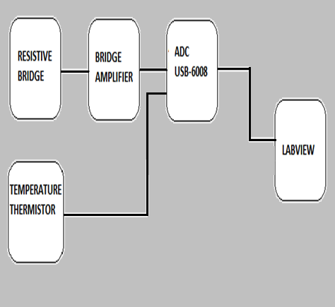 Figure 2.2 Project block diagram

* Resistive bridge is the four foil strain gauge (described in detail in Part ??????)
* The resistive bridge is connected to the bridge amplifier(RS>>>>>>) ,
* The bridge amplifier will control the bridge supply and amplify the difference between the voltage output of the Wheatstone resistive bridge of the strain gauges
* Converted to a digital signal through the DAQ
* Temperature thermistor is used to compensate for any temperature change that would occur.( Described in detail in part) and converter to digital by the DAQ and used in the temperature compensation.

## 1.3 Application of Strain Gauge

The strain gauge has been in use for many years and is the fundamental sensing element for many types of sensors. The majority of strain gauges are foil types, available in a wide choice of shapes and sizes to suit a variety of applications. They consist of a pattern of resistive foil which is mounted on a backing material. They operate on the principle that as the foil strain gauge on the test specimen is subjected to stress, the resistance of the foil strain gauge changes. Strain gauges are used in an increasing number of applications in all kinds of industry world-wide. Some examples of industries where strain gauges are user are: - **[4]**

* In load cells for weighbridges, scales, hoppers, vehicles and in medical and educational applications.
* For monitoring structures such as bridges and buildings.
* In research and development applications, including automotive, aerospace, medical, process, oil and gas, and power generation.

1.4 Structure of report

This project report is structure as a typical lab report Strain gauges are described detail of how they evolved in chapter one. This chapter also mentions the various applications of strain gauges sensors, also chapter one discusses the main aims of this project that will be hopefully achieved by the end of the project.

Chapter two introduces the strain gauges theory, detailing how foil strain gauges work and how using foil strain gauges a strain at specific point can be determined. This chapter also discusses how a strain at specific point can be calculated mathematically so that measured strain can be compared to theoretical strain at specific point. This chapter also introduces a voltage potential divider theory, detailing how using voltage potential divider temperature of the test specimen can be determined.

Chapter three includes a detailed explanation of the sensors that are used in this project and gives detailed explanation of the measuring circuit configurations that would achieve a best result for the particular sensor. It also discusses a potential errors associated with measuring strain and temperature and steps taken to minimise them.

Chapter four details the circuitry used to amplify a voltage from a Wheatstone bridge configuration, the ADC (analog to digital converter) used to convert signal from analog into digital form so it can be manipulated in LabView and AD7190 evaluation board used to transmit signal from ADC to computer. It also mentions any problems encountered during the course of this project and also considerations that were taken into account to reduce any factors that may affect measurements.

Chapter five examines the details of the software for the data acquisition system which was developed for this project to enable readings to be taken from the sensors LabView graphical programming language software package was used to graph and display strain in real time, acquired from the strain gauges through AD7190 evaluation board.

Chapter six details the experimental setup and results of the two strain gauge systems that were obtained through experiments. In this chapter also a theoretical aspect of experiments is compared with the practical aspect.

Chapter seven

.

.

.

Chapter eight summaries the report and talks about the conclusion reached from the experimental results. It also mentions further future developments which could be explored in the area of sensors and data acquisition for sensor system

Part 2: Objective

This project is a has several objectives

1. Understanding the operation of foil strain gauges.
2. If a strip of conductive metal is stretched, it will become skinnier and longer, both changes resulting in an increase of electrical resistance end-to-end. Conversely, if a strip of conductive metal is placed under compressive force (without buckling), it will broaden and shorten. If these stresses are kept within the elastic limit of the metal strip (so that the strip does not permanently deform), the strip can be used as a measuring element for physical force, the amount of applied force inferred from measuring its resistance.
3. Such a device is called a *strain gauge*. Strain gauges are frequently used in mechanical engineering research and development to measure the stresses generated by machinery. Aircraft component testing is one area of application, tiny strain-gauge strips glued to structural members, linkages, and any other critical component of an airframe to measure stress. Most strain gauges are smaller than a postage stamp, and they look something like this:
4. 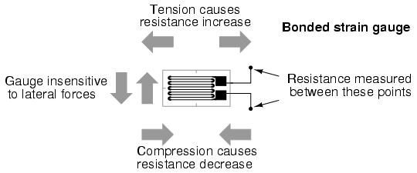
5. A strain gauge's conductors are very thin: if made of round wire, about 1/1000 inch in diameter. Alternatively, strain gauge conductors may be thin strips of metallic film deposited on a nonconducting substrate material called the *carrier*. The latter form of strain gauge is represented in the previous illustration. The name "bonded gauge" is given to strain gauges that are glued to a larger structure under stress (called the *test specimen*). The task of bonding strain gauges to test specimens may appear to be very simple, but it is not. "Gauging" is a craft in its own right, absolutely essential for obtaining accurate, stable strain measurements. It is also possible to use an unmounted gauge wire stretched between two mechanical points to measure tension, but this technique has its limitations.
6. Typical strain gauge resistances range from 30 Ω to 3 kΩ (unstressed). This resistance may change only a fraction of a percent for the full force range of the gauge, given the limitations imposed by the elastic limits of the gauge material and of the test specimen. Forces great enough to induce greater resistance changes would permanently deform the test specimen and/or the gauge conductors themselves, thus ruining the gauge as a measurement device. Thus, in order to use the strain gauge as a practical instrument, we must measure extremely small changes in resistance with high accuracy.

1. Design of a suitable resistive bridge.
2. Such demanding precision calls for a bridge measurement circuit. Unlike the Wheatstone bridge shown in the last chapter using a null-balance detector and a human operator to maintain a state of balance, a strain gauge bridge circuit indicates measured strain by the degree of *imbalance*, and uses a precision voltmeter in the center of the bridge to provide an accurate measurement of that imbalance:
3. 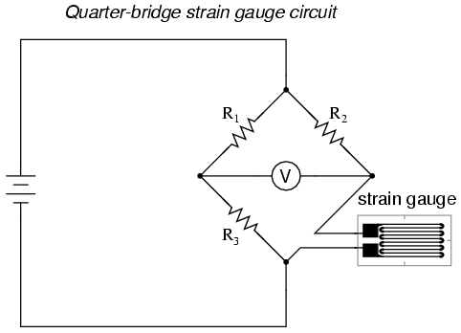
4. Typically, the rheostat arm of the bridge (R2 in the diagram) is set at a value equal to the strain gauge resistance with no force applied. The two ratio arms of the bridge (R1 and R3) are set equal to each other. Thus, with no force applied to the strain gauge, the bridge will be symmetrically balanced and the voltmeter will indicate zero volts, representing zero force on the strain gauge. As the strain gauge is either compressed or tensed, its resistance will decrease or increase, respectively, thus unbalancing the bridge and producing an indication at the voltmeter. This arrangement, with a single element of the bridge changing resistance in response to the measured variable (mechanical force), is known as a *quarter-bridge* circuit.
5. As the distance between the strain gauge and the three other resistances in the bridge circuit may be substantial, wire resistance has a significant impact on the operation of the circuit. To illustrate the effects of wire resistance, I'll show the same schematic diagram, but add two resistor symbols in series with the strain gauge to represent the wires:
6. 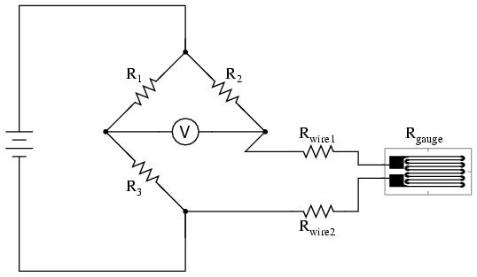
7. The strain gauge's resistance (Rgauge) is not the only resistance being measured: the wire resistances Rwire1 and Rwire2, being in series with Rgauge, also contribute to the resistance of the lower half of the rheostat arm of the bridge, and consequently contribute to the voltmeter's indication. This, of course, will be falsely interpreted by the meter as physical strain on the gauge.
8. While this effect cannot be completely eliminated in this configuration, it can be minimized with the addition of a third wire, connecting the right side of the voltmeter directly to the upper wire of the strain gauge:
9. 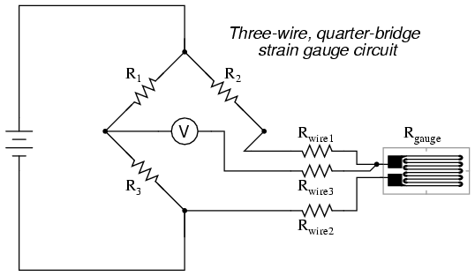
10. Because the third wire carries practically no current (due to the voltmeter's extremely high internal resistance), its resistance will not drop any substantial amount of voltage. Notice how the resistance of the top wire (Rwire1) has been "bypassed" now that the voltmeter connects directly to the top terminal of the strain gauge, leaving only the lower wire's resistance (Rwire2) to contribute any stray resistance in series with the gauge. Not a perfect solution, of course, but twice as good as the last circuit!
11. There is a way, however, to reduce wire resistance error far beyond the method just described, and also help mitigate another kind of measurement error due to temperature. An unfortunate characteristic of strain gauges is that of resistance change with changes in temperature. This is a property common to all conductors, some more than others. Thus, our quarter-bridge circuit as shown (either with two or with three wires connecting the gauge to the bridge) works as a thermometer just as well as it does a strain indicator. If all we want to do is measure strain, this is not good. We can transcend this problem, however, by using a "dummy" strain gauge in place of R2, so that *both*elements of the rheostat arm will change resistance in the same proportion when temperature changes, thus canceling the effects of temperature change:
12. 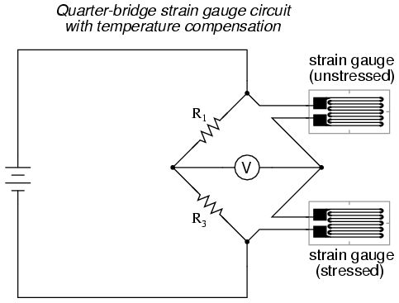
13. Resistors R1 and R3 are of equal resistance value, and the strain gauges are identical to one another. With no applied force, the bridge should be in a perfectly balanced condition and the voltmeter should register 0 volts. Both gauges are bonded to the same test specimen, but only one is placed in a position and orientation so as to be exposed to physical strain (the *active* gauge). The other gauge is isolated from all mechanical stress, and acts merely as a temperature compensation device (the *"dummy"* gauge). If the temperature changes, both gauge resistances will change by the same percentage, and the bridge's state of balance will remain unaffected. Only a differential resistance (difference of resistance between the two strain gauges) produced by physical force on the test specimen can alter the balance of the bridge.
14. Wire resistance doesn't impact the accuracy of the circuit as much as before, because the wires connecting both strain gauges to the bridge are approximately equal length. Therefore, the upper and lower sections of the bridge's rheostat arm contain approximately the same amount of stray resistance, and their effects tend to cancel:
15. 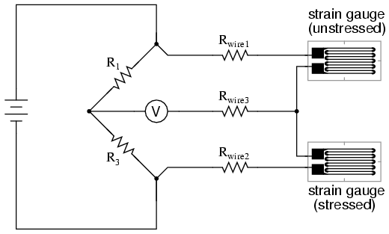
16. Even though there are now two strain gauges in the bridge circuit, only one is responsive to mechanical strain, and thus we would still refer to this arrangement as a *quarter-bridge*. However, if we were to take the upper strain gauge and position it so that it is exposed to the opposite force as the lower gauge (i.e. when the upper gauge is compressed, the lower gauge will be stretched, and vice versa), we will have*both* gauges responding to strain, and the bridge will be more responsive to applied force. This utilization is known as a *half-bridge*. Since both strain gauges will either increase or decrease resistance by the same proportion in response to changes in temperature, the effects of temperature change remain canceled and the circuit will suffer minimal temperature-induced measurement error:
17. 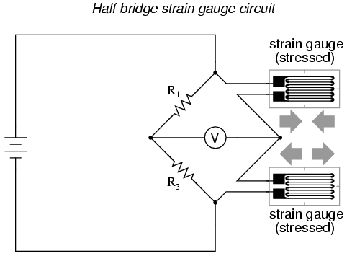
18. An example of how a pair of strain gauges may be bonded to a test specimen so as to yield this effect is illustrated here:
19. 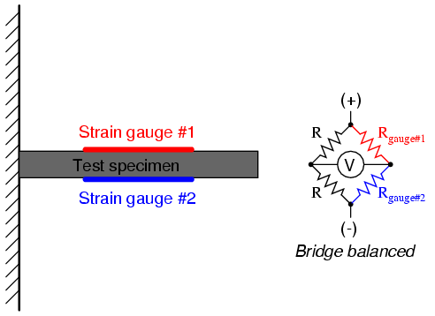
20. With no force applied to the test specimen, both strain gauges have equal resistance and the bridge circuit is balanced. However, when a downward force is applied to the free end of the specimen, it will bend downward, stretching gauge #1 and compressing gauge #2 at the same time:
21. 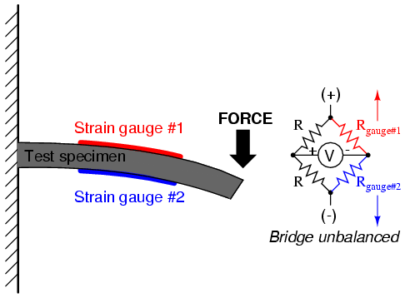
22. In applications where such complementary pairs of strain gauges can be bonded to the test specimen, it may be advantageous to make all four elements of the bridge "active" for even greater sensitivity. This is called a *full-bridge* circuit:
23. 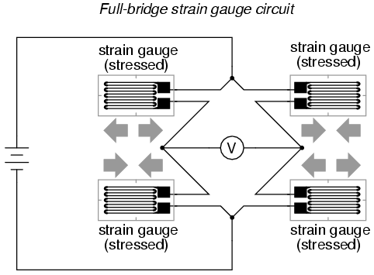
24. Both half-bridge and full-bridge configurations grant greater sensitivity over the quarter-bridge circuit, but often it is not possible to bond complementary pairs of strain gauges to the test specimen. Thus, the quarter-bridge circuit is frequently used in strain measurement systems.
25. When possible, the full-bridge configuration is the best to use. This is true not only because it is more sensitive than the others, but because it is *linear* while the others are not. Quarter-bridge and half-bridge circuits provide an output (imbalance) signal that is only *approximately*proportional to applied strain gauge force. Linearity, or proportionality, of these bridge circuits is best when the amount of resistance change due to applied force is very small compared to the nominal resistance of the gauge(s). With a full-bridge, however, the output voltage is directly proportional to applied force, with no approximation (provided that the change in resistance caused by the applied force is equal for all four strain gauges!).
26. Unlike the Wheatstone and Kelvin bridges, which provide measurement at a condition of perfect balance and therefore function irrespective of source voltage, the amount of source (or "excitation") voltage matters in an unbalanced bridge like this. Therefore, strain gauge bridges are rated in millivolts of imbalance produced *per* volt of excitation, *per* unit measure of force. A typical example for a strain gauge of the type used for measuring force in industrial environments is 15 mV/V at 1000 pounds. That is, at exactly 1000 pounds applied force (either compressive or tensile), the bridge will be unbalanced by 15 millivolts for every volt of excitation voltage. Again, such a figure is precise if the bridge circuit is full-active (four active strain gauges, one in each arm of the bridge), but only approximate for half-bridge and quarter-bridge arrangements.
27. Strain gauges may be purchased as complete units, with both strain gauge elements and bridge resistors in one housing, sealed and encapsulated for protection from the elements, and equipped with mechanical fastening points for attachment to a machine or structure. Such a package is typically called a *load cell*.
28. Like many of the other topics addressed in this chapter, strain gauge systems can become quite complex, and a full dissertation on strain gauges would be beyond the scope of this book.
29. Signal acquisition using an A/D acquisition card.

Using the National instruments USB 6008 (ADC) in the begin of this project a simple interface VI, was built and would output the results for the experimental resistive bridges in a graphical user interface. See chapter 7. While investigations of the other components also began in the first six weeks i.e. the amplifier that would amplify the output for the resistive bridges, see chapter 4, the investigation and sourcing the components needed to fully accomplish this project.

1. Signal processing using LabView including real-time display of the strain.

Part 3: Theory

3.1 Foil strain gauge

3.1a History of the strain gauge

## 3.1b History

Professor Arthur Ruge felt differently about his strain gauge. Ruge invented the device in 1938 to help his graduate student John Meier complete his investigation of earthquake stress on elevated water tanks. It was simple: a tiny piece of high-resistance filament was bent in a zigzag pattern and fixed in a rigid base (glue). The gauge was applied to the surface he wanted to test. Any stress on the surface could be easily detected by measuring the changes in electrical resistance of the current running through the wires of the gauge. Having been granted full rights to his invention, Ruge began the patent application process. Discovering that E.E. Simmons of Caltech had invented the same device a year earlier, the two men together applied for the patent. In 1939, Ruge started a business with MIT Professor Alfred deForest to manufacture the SR-4 gauge (the initials S and R honor the inventors), a device used in virtually all commercial weighing scales, in every structural stress test—and it even allowed astronaut Neil Armstrong to declare: “The Eagle has landed.” http://museum.mit.edu/150/82

## 3.1c Application of Strain Gauge

The strain gauge have been in use for many years and is the fundamental sensing element for many types of sensors. The majority of strain gauges are foil types, available in a wide choice of shapes and sizes to suit a variety of applications. They consist of a pattern of resistive foil which is mounted on a backing material. They operate on the principle that as the foil strain gauge on the test specimen is subjected to stress, the resistance of the foil strain gauge changes. Strain gauges are used in an increasing number of applications in all kinds of industry world-wide. Some examples of industries where strain gauges are user are: - **[4]**

* In load cells for weighbridges, scales, hoppers, vehicles and in medical and educational applications.
* For monitoring structures such as bridges and buildings.
* In research and development applications, including automotive, aerospace, medical, process, oil and gas, and power generation.

It was due to the demands of rapidly growing industry that the important advance into foil strain gauges was made.

In 1952 Saunders-Roe Company based in United Kingdom were seeking improvements in the performance of the bonded wire gauges to enable their use in more demanding environment. During that time a printed circuit boards were emerging and Saunders-Roe developed the idea of making a strain gauge by etching the pattern for the gauge from a thin foil. **[3]** These newly developed foil strain gauges had some district advantage to the previous ancestors and most notably there was reduction in size and production costs. A structure of the typical strain gauge can be seen in Figure 1.2.1.

This allowed much more extensive use of electrical resistance strain gauges, and they are the most common type in use today.

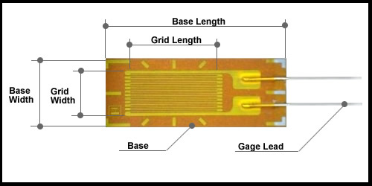

Figure 2.1

A Strain gauge is a sensor whose resistance varies with applied force; it’s converts force, pressure, tension, weight, etc., into a change in electrical resistance which can then be measured. When the gauge is place in a Wheatstone configuration and onto the length of steel a weight will be applied this will cause strain on the foil gauges changing the length of the grid and is resistance .Stress is defined as the object's internal resisting forces, and strain is defined as the displacement and deformation that occur.

## 3.1 d

## Potential Errors and Solutions

There are many potential errors associated with foil strain gauges and thermistors. The main ones, and possible solutions to the problems, are outlined below.

### 3.4.1 Foil Strain Gauge Sensor

#### 3.4.1.1 Mounting Error

Some of the foil strain gauges may be damaged during installation. It is important therefore to check that the resistance of the all strain gauges is same prior to applying any load onto test specimen.

The resistance of the electrical conductor changes with a ratio of { $\frac{ΔR}{R}$, (R = resistance)} as a stress is applied such that its length changes by a factor { $\frac{ΔL}{L}$,( L = Length)} as the strain gauge is stressed the grid will change length becoming thinner or denser dependent on the strain applied.

**Gauge factor** (GF) or **strain factor** of a strain gauge is the ratio of relative change in electrical resistance R, to the mechanical strain  ε. The gauge factor is defined as: [([1])](http://en.wikipedia.org/wiki/Gauge_factor)

Where

* ε = strain = \Delta L / Lo
  + GF = \frac{\frac{\Delta R}{R}}{\varepsilon} = \frac{\frac{\Delta\rho}{\rho}}{\varepsilon} + 1 + 2\nu \Delta L= absolute change in length
  + Lo= original length
* ν = Poisson’s ration
* ρ = Resistivity
* ΔR = change in strain gauge resistance
* R = unstrained resistance of strain gauge

3.2 Cantilever theory

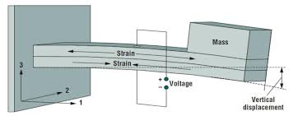

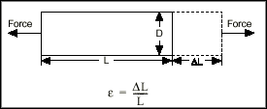

A strain experienced by the length of steel when there is force applied can be calculated mathematically. There is a direct relationship between strain and stress. Due to that fact a stain at particular point can be calculated using Hooks Law: - **[7]** which states which states that, for relatively small [deformations](http://www.britannica.com/EBchecked/topic/155875/deformation-and-flow) of an object, the[displacement](http://www.britannica.com/EBchecked/topic/165821/displacement) or size of the deformation is directly proportional to the deforming force or load. Under these conditions the object returns to its original shape and size upon removal of the load.

|  |  |  |  |
| --- | --- | --- | --- |
| *ε = $\frac{σ }{E}$* | ε= extensional strain | $σ$ is tensile stress | $E$ is Modulus of Elasticity. |
|  |  |  |  |
|  |  |  |  |

Different types of materials will have different Young’s Modulus of Elasticity. Steel Young’s Modulus of Elasticity ($E$) = 69 ${10}^{9}$* N/ **[8]**

To be able to use Hooks Law to calculate extensional strain, tensile stress at specific point needs to be calculated first: - **[9]**

*=*

where $σ$ is tensile stress at specific point, $W$ is load in Newton(N), $l$ is distance between $W$ and foil strain gauge mounting point in meters (m) and $Z$ is section modulus of the cross-section of the beam in meters squared (m2). As seen in Figure 2.2.1.

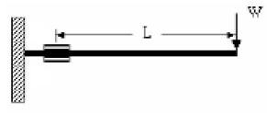

Figure 2.2.1: Cantilever Beam with Tip Load.

Weight that is suspended on the end of the test specimen needs to be converted into Newton, therefore:-

$Weight$ = F (N) = Mass (kg) * Acceleration of Gravity $(m/s^{2})$

where Acceleration of Gravity is 9.8 $m/s^{2}$. A last step in calculating tensile stress is to determine $Z$ a section modulus of the cross-section of the beam: - **[10]**

*=*

where $Z$ is section modulus of the cross-section of the beam, $b$ is width of rectangular beam in meters (m) and h is height of rectangular beam in meters (m). As illustrated in Figure 2.2.2.

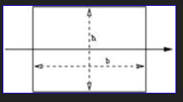

Figure 2.2.2: Cross-section few of rectangular beam

**Strain at specific point is**

***ε = $\frac{W \left(l\right)}{(\frac{bh^{2}}{6})(E)}$***

**5.3 Voltage divider**

A voltage divider is a simple circuit which turns a large voltage into a smaller one. Using just two series resistors and an input voltage, if can create an output voltage that is a fraction of the input. The voltage divider in figure 5.3 will convert the resistive thermistor measurement into voltage that can be used by the ADC to convert into temperature. If the voltage measurement is to low a pot(variable resistance can be replaces by R2.

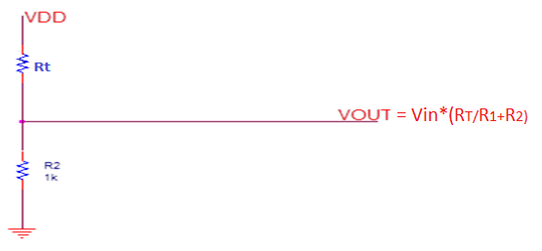

Figure 5.3

Figure 2.1 shows the voltage divider circuit output, whose voltage is **directly proportional** to the **input voltage.**

**Conclusion: The stain measurement is affected by temperature using the correct temperature measurement is necessary to record the correct strain measurement. The initial results for my investigations of the temperature, will begin with the thermistor, and an adjustment onto the thermocouple may be necessary**

When foil strain gauge reading can be affected by temperature this is compensated for in this project by using a thermistor. The Change in temperature will be converted in a resistance and the subtracted/ added depending on the change in temperature. But to accrue the correct signal the resistance from the thermistor has to converted into a voltage by the use of the potential divider circuit

In potential divider circuit R2 is replaced with thermistor as seen in Figure 3.3.1. Unknown thermistor resistance needs to be calculated to determine surface temperature of aluminium metal beam.

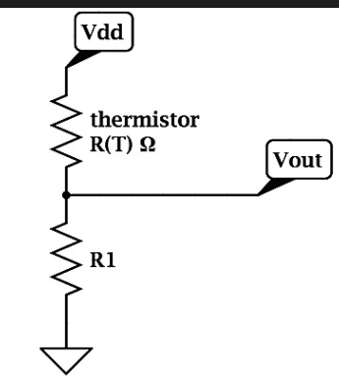

Figure 3.3.1: Thermistor potential divider circuit.

Calculating resistance of thermistor to determine surface temperature of aluminium metal beam:-

*Vout = $\frac{R2}{R1+R2 }*Vin$*

so *R2 = R1 $\frac{1}{(\frac{Vin}{Vout}-1)}$

\**

where *Vout* is an output voltage from potential divider circuit in Volts (V), $R2$ is an unknown resistance of thermistor in Ohms (Ω), $R1$ is a known fixed resistor value in Ohms (Ω) which is usually a resistance produced by thermistor at 25˚C and $Vin$ is a supply voltage to potential divider circuit in Volts (V). **[11]**

Any ratio $\frac{Vin}{Vout}$ greater than 1 is not possible.

5:4 Effect of Temperature

3.3 Temperature Theory

In this chapter, the focus will be on investigating the temperature measurement options that are available to measure the temperature that will affect the strain measurement. While compensated gages reduce the thermal sensitivity, they do not totally remove it. Therefore, additional temperature compensation is sometimes necessary.  
  
Further correction is possible by measuring temperature and using a correction curve to correct the data. Manufacturers print the polynomial coefficients of this curve to fourth order on each package of gages (see Figure 2 below). With the coefficients you can conduct temperature correction in software. An error as small as 1 me/°C is possible using this technique.

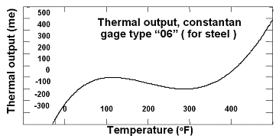  
**Figure 2 Thermal Output Rating [3]**

### 3.4 Wheatstone bridge Configuration

Wheatstone bridge configuration was used to determine strain experienced by an aluminium beam when there is a load suspended at the end of the beam. In Wheatstone bridge circuit configuration unknown resistances are compared with well defined resistances. The Whaetstone bridge is also well suited for the measurment of small changes of a resistance and is therefore also suitable for measuring the resistance change in a foil strain gauge.

After conducting in depth research on different types of Wheatstone bridge configurations it was decided that full Wheastone bridge configuration will be used. In the full-bridge strain gauge circuit R1, R2, R3 and R4 are all replaced with strain gauges as seen in Figure 3.5.1.1.

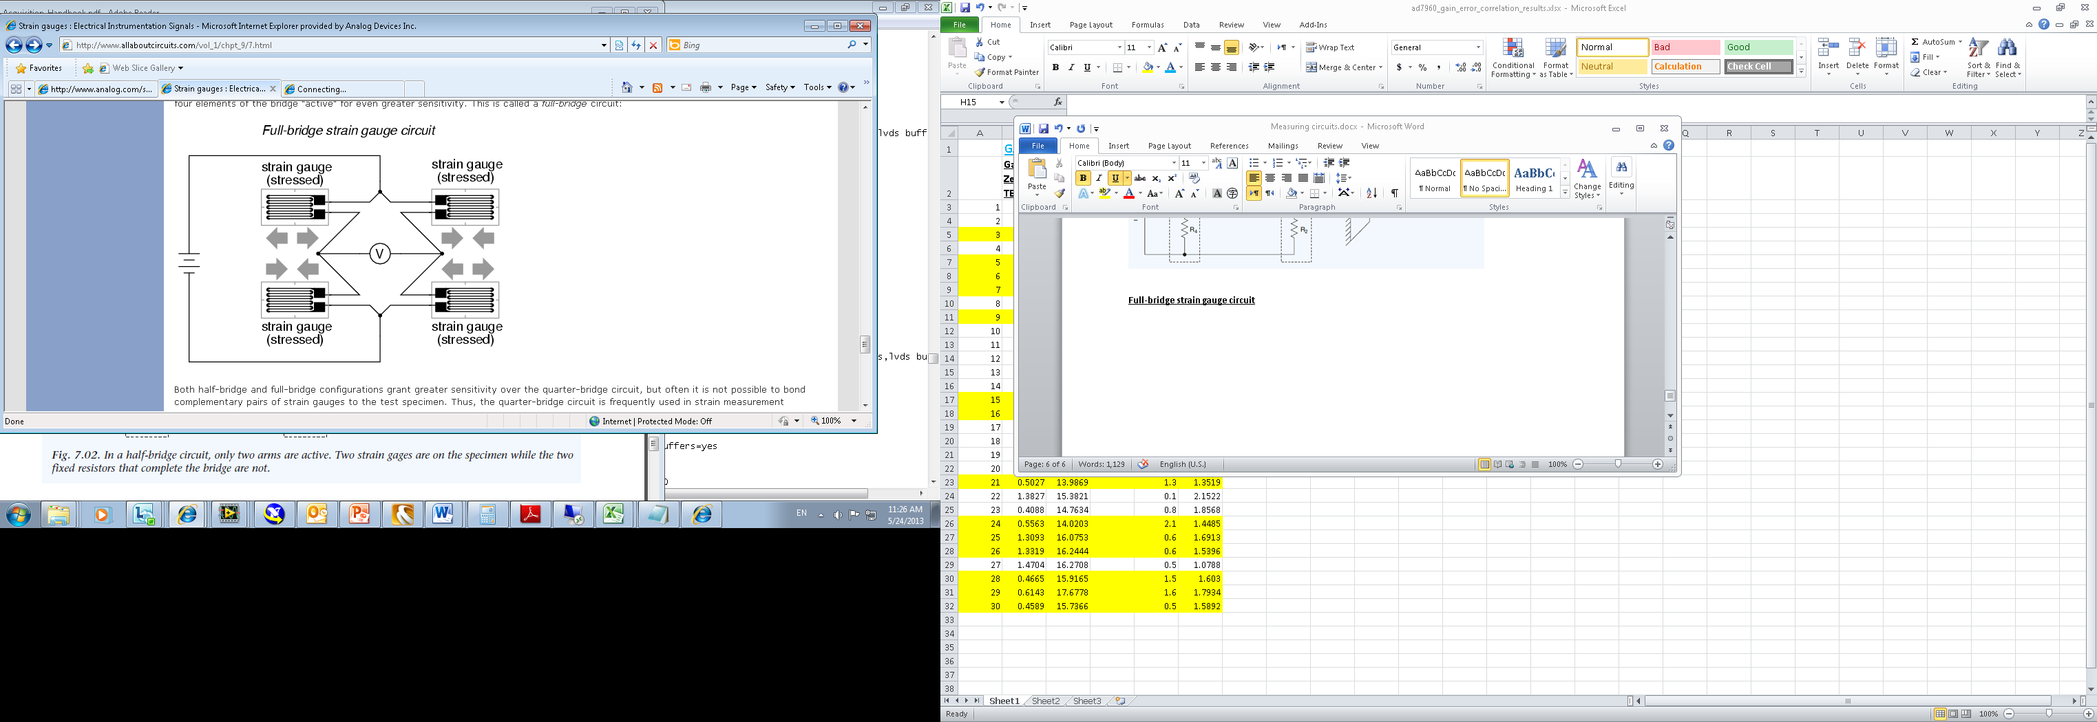

Figure 3.5.1.1: Full-bridge strain gauge circuit.

With no force applied to the test specimen all four strain gauges have equal resistance and the bridge circuit is balanced. In the full-bridge configuration two gauges are mounted on the surface under tension and the other two are mounted on the opposite surface under compression as seen in Figure 3.5.1.2. **[18]**

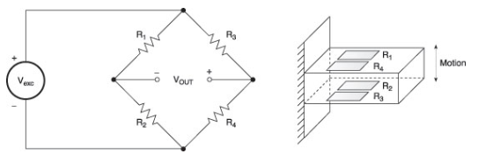

Figure 3.5.1.2: Placement of strain gauges onto test specimen.

As a force is applied on a test specimen, the two gauges in tension increase in resistance while the other two decrease unbalancing the bridge and producing an output proportional to the displacement. Full-bridge arrangment grants greater sensitivity over half-bridge and quarter-bridge arrangments. The full-bridge configuration provides the highest sensitivity and because the full-bridge produces highest output voltage, noise is a less significant factor in the measurments.This is only configuration that is linear while quarter-bridge and half-bridge configurations are not. Quater-bridge and half-bridge configuration circuits provide an imbalanced output signal that is only approximately proportional to applied strain gauge force. Full-bridge circuit also compensates for temperature variation and lead resistance which play a significant part in measurements. **[19]**

## 3.7 Sensor Placement

Foil Strain gauge sensors were placed on the test specimen in such a manner so it can be shown that strain experienced by the aluminium rod depend on the distance between anchor point and the foil strain gauges location point when there is load suspended on the end of a rod. Two separate full-bridge Wheatstone circuit configurations were used. After conducting theoretical calculations it was determine that one strain gauge system be placed 110mm, and the second system 230mm, from anchor point. Figure 3.7.1 shows the placement of sensors on the aluminium rod. Theoretically by placing foil strain gauges in this positions the strain measurements from system one should be more than twice the strain measurement observed from system two. By plotting result on one graph will demonstrate that a strain experienced by the bend aluminium rod is greater closer to anchor point and reduces as you move away from anchor point closer to suspended load location.

Betatherm-10k3a542i NTC thermistor sensor was placed between two foil strain gauge systems to determine surface temperature of the aluminium rod.

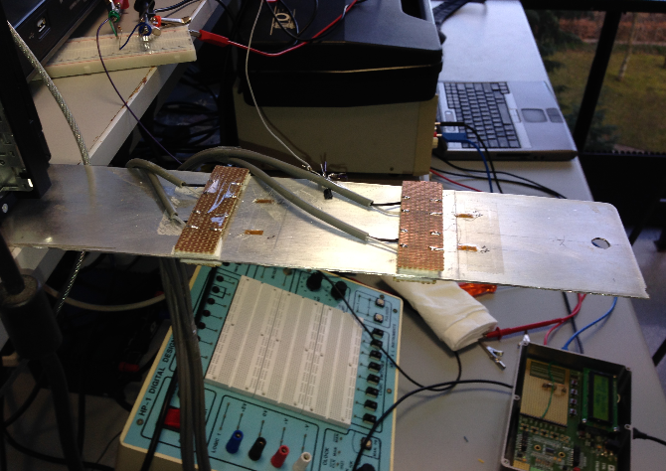

Figure 3.7.1: Sensor location on the test specimen.

### 3.5.2 Testing Wheatstone bridge configuration

To make sure that the Wheatstone bridge configuration resistive circuit will work for this project. At the start the quarter-bridge circuit configuration was built on the copper strip board using three 120Ω fixed resistors and 200Ω variable resistor (pot). A ±9V supply was used to power up the circuit. From the Figure 3.5.2.1 below it can be seen the way circuit was connected up. By varying the resistance of the pot Wheatstone bridge configuration output voltage changed which proved the theoretical aspect of the circuit. Only noticeable issue with this configuration as expected was that the output voltage was very small which made it hard to read.

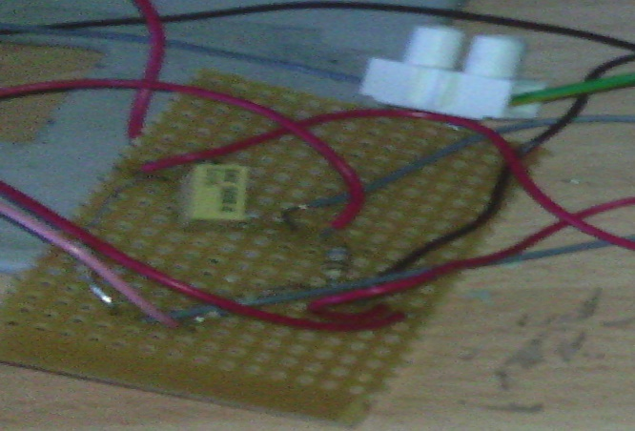

Figure 3.5.2.1. Quarter-circuit Wheatstone bridge configuration.

The next step was to replace all of the resistors with the foil strain gauges, each foil strain gauge acts as 120Ω variable resistor. All four foil strain gauges were connected up in the full-bridge circuit configuration and mounted onto the test specimen as seen in Figure 3.5.2.2. A ± 5V supply was used to power up the circuit. At the start with no force applied full-bridge circuit output voltage was almost 0V which meant that circuit is balanced. As the up-wards force or down-words force was applied onto test specimen the output voltage changed. Which mean that this configuration is working correctly and can be implemented for this project. It was also noticed as expected the output voltage from the circuit was significantly bigger than quarter-bridge circuit output voltage which meant it was more accurate and easier to read. After a first system was in full working order it was replicated and a second strain gauge system was build and placed at different point on a test specimen.

A LabView program was developed at later stage that converted voltage into strain and displayed strain measurements graphically on the front panel.

: Resistive Bridge Design

Throughout the investigation of the resistive bridge the results have concluded, that to get the balanced output from the foil strain gauge while under no strain the Wheatstone bridge is the resistive bridge that will give the correct results, and is the selected resistive bridge for this project.

In this chapter the Wheatstone resistive bridge operation will be discussed and how it will interact with the amplifier.

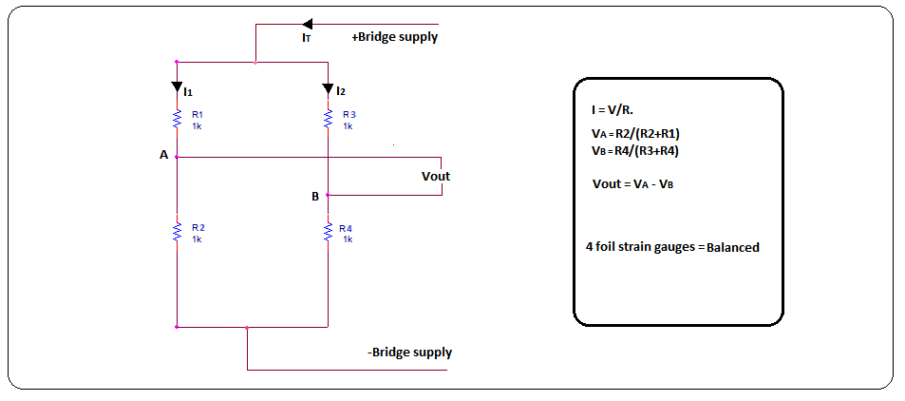

Figure 4.1

In Figure 4.1 shows the Wheatstone bridge. When the bridge voltage is applied the output voltage would be in microvolts. They operate on the principle that as the foil is subjected to stress, the resistance of the foil changes in a defined way, when all the foil strain gauges are without strain the Vout is 0V, as seen in figure 4.2. When a force (weight) is applied to the Test Specimen (steel), the foil gauges 1 &2 become thinner and foil gauges 2&3 become denser, making the resistive bridge unbalanced , defining the Gauge Factor(GF) of the unbalanced as ∆ Resistance due to ∆ in Length.

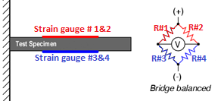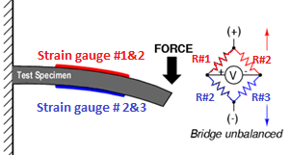

Figure 4.2 Figure 4.3 [2]

3.5 Amplifer

## 4.2 Strain Gauge Amplifier

After conducting some research it was noticed that the output voltage from the full-bridge circuit configuration will be very small which could result in an inaccurate readings due to noise and other surrounding factors interfering with signal. So it was decided that an output voltage from full-bridge Wheatstone circuit configuration needs to be amplified so that it is more accurate and more readable. To amplify incoming signal a specially designed strain gauge amplifier was used within a circuit. The strain gauge amplifier is a purpose designed hybrid, low noise, low draft, linear dc amplifier in a 24 pin DIL package specifically configured for a resistive measurement circuit such as Wheatstone bridge configuration. **[22]** The pin out for strain gauge amplifier can be seen in Figure 4.2.1.1.

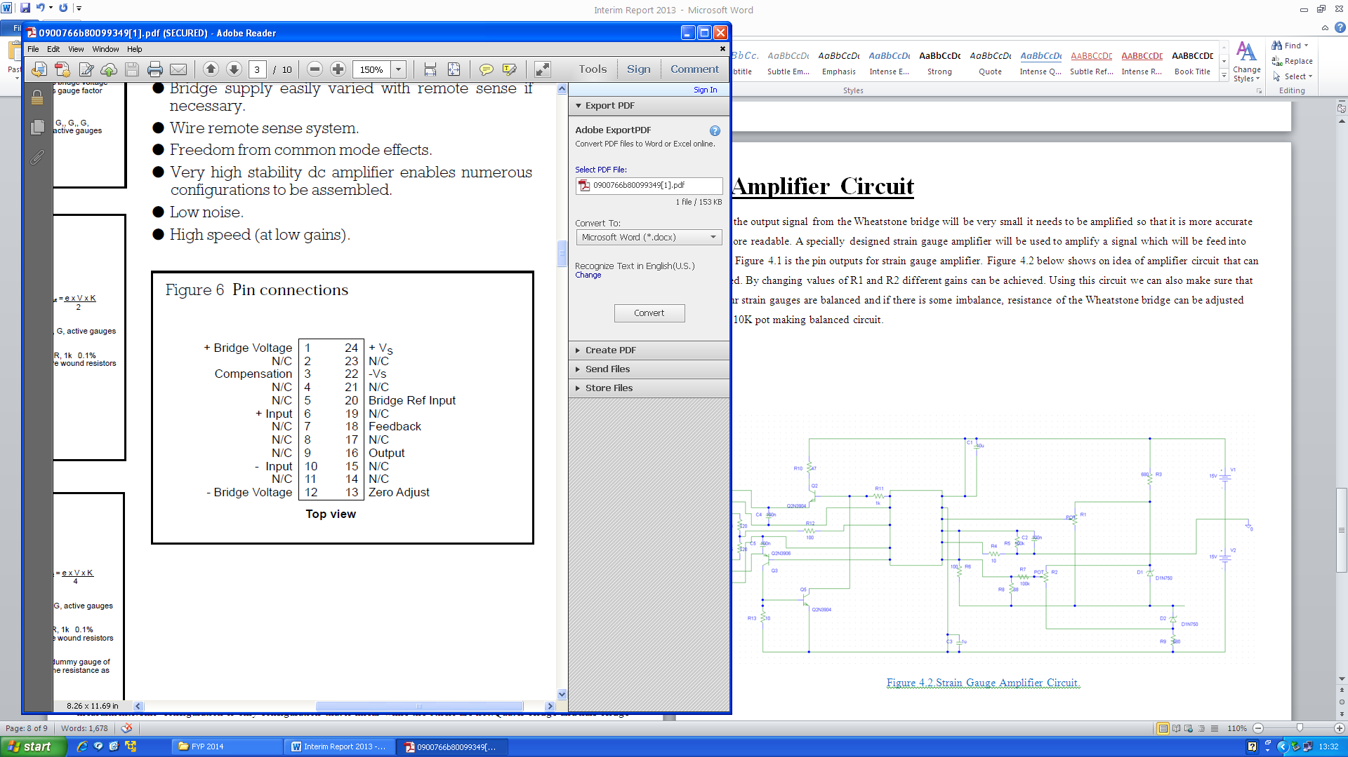

Figure 6.1 RS 846-171 amplifier [6]

This amplifier will amplifier the Resistive bridge output (Vout), this Vout will be amplifier by a gain of 1000 as to be able view the vout. The advantage of using this amplifier is no common mode rejection; Common mode rejection represents any signals that are common to both inputs (VS and –Vs.)

Overall output from the full circuit Wheatstone bridge could be only 1 mV on a common mode voltage of 9V may be encountered as aluminium beam is subjected to strain, requiring exceptional common mode rejection which be provided by conventional means. The strain gauge amplifier overcomes the problem of common mode rejection by removing the common mode voltage. This is achieved by controlling the negative bridge supply voltage in such a manner that the voltage at the negative bridge supply terminal is always zero. Thus for a symmetrical bridge, a voltage on the negative bridge supply is equal but opposite of the positive bridge supply voltage, hence zero common mode. **[23]**

The advantages of such as system are:

* No floating power supply needed.
* Bridge supply voltage can be easily varied to balance a system.
* Wire remote sense system.
* Freedom from common amplifier.
* Low noise.
* High Speed at low gains.

### 4.2.2 Strain Gauge Amplifier Circuit

The strain gauge circuit below in Figure 4.2.2.1 was specially designed for the strain gauge amplifier. This amplification circuit is designed so that its supplies a voltage to the full-bridge circuit configuration and obtains the output voltage which is then directly fed into a strain gauge amplifier. The output voltage from the Wheatstone bridge configuration that is fed into strain gauge amplifier is differential and a voltage coming out of stain gauge amplifier is single voltage, which is very useful as rather than using differential inputs on ADC, pseudo differential inputs can be used allowing more signals to be fed into ADC at once as there are two differential inputs and four pseudo differential inputs on ADC. A strain gauge amplification circuit was power up using ±9V power supplies. **[24]**

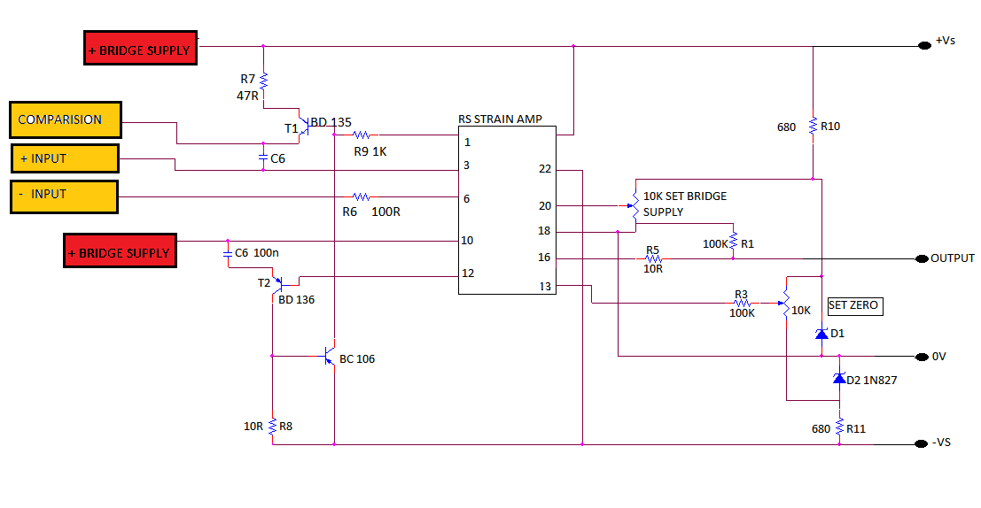Figure 6 the strain gauge amplifier

A strain gauge amplifier works on the principle of operational amplifier. A gain in this amplification circuit was set using two resistors R1 and R2 as seen in Figure 4.2.2.2.

Gain = $\frac{1+R1}{R2}$

After conducting some research it was decided not to set very large gain on a signal because then all of the noise present in the circuit would be amplified making the strain gauge system hard to balance and readings would be inaccurate. Initially a gain of 101 was used which gave accurate and readable results. But it was noticed that when this signal was fed into ADC board it was significantly larger than the maximum input voltage allowed for the AD7190. So the gain was reduced from 101 to 11 this had no detrimental effect on the accuracy of the system but reduced the output voltage from strain gauge circuit to the level that AD7190 could operate comfortably. R1 was set to 100kΩ and R2 was set to 10kΩ providing required gain.

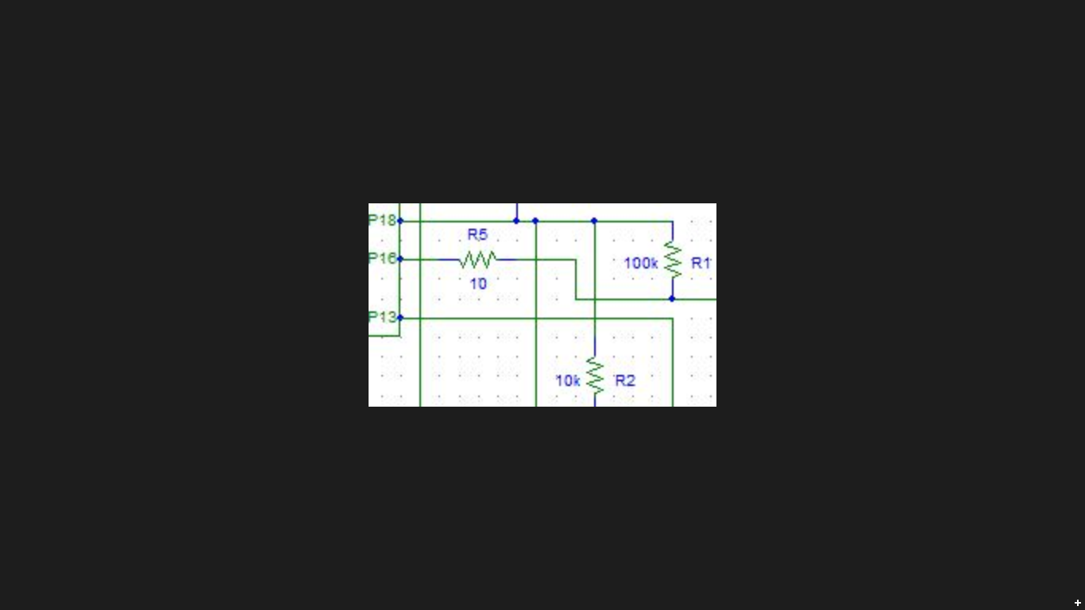

Figure 4.2.2.2: Setting strain gauge amplifier gain.

As resistance from strain gauge to strain gauge can slightly vary. A 10 kΩ variable resistor (pot) in the strain gauge amplifier circuit was used to balance a system by adjusting the output voltage from the full-bridge circuit configuration as seen in Figure 4.2.2.3. By having 0mV output from a strain gauge system when test specimen is experiencing no strain means that system is balanced.

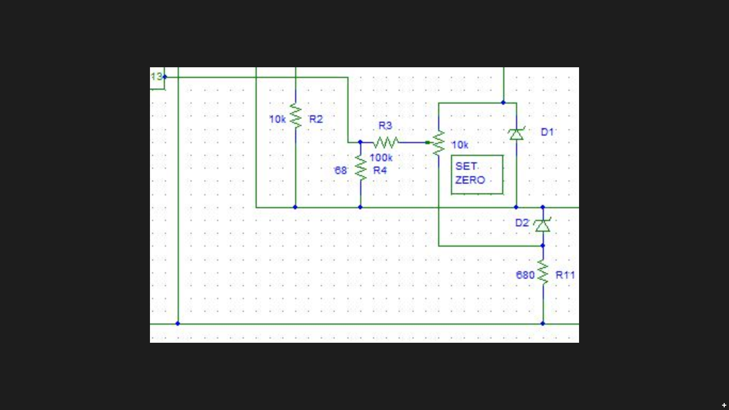

Figure 4.2.2.3: 10 kΩ variable resistor pot to balance strain gauge system.

Another10 kΩ variable resistor in the strain gauge amplifier circuit was used to adjust a bridge supply voltage as seen in Figure 4.2.2.4. As for a symmetrical bridge, a voltage on the negative bridge supply needs to be equal but opposite of the positive bridge supply voltage to have zero common mode. This is required to achieve accurate readings from the full-bridge circuit configuration.

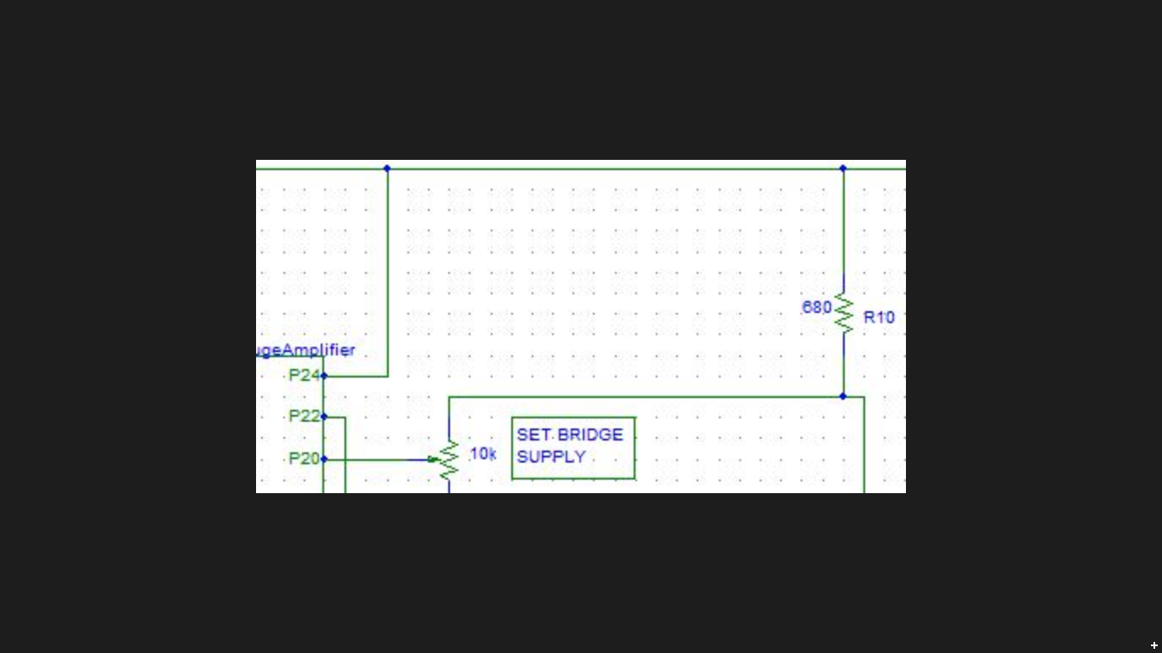

Figure 4.2.2.4: 10 kΩ variable resistor pot to adjust bridge supply.

BD 135 and BD 136 transistors are NPN and PNP transistors respectively. They are pull up and pull down transistors which means that they will provide constant balanced current to the Wheatstone bridge configuration as seen in Figure 4.2.2.5. They were used because after modelling full circuit Wheatstone bridge configuration in PSpice it was noticed that each foil strain gauge sensor intakes on average of 380µA. BD 135 and BD 136 provide bridge current up to 60mA. A PSpice modulation can be seen in Appendix D.

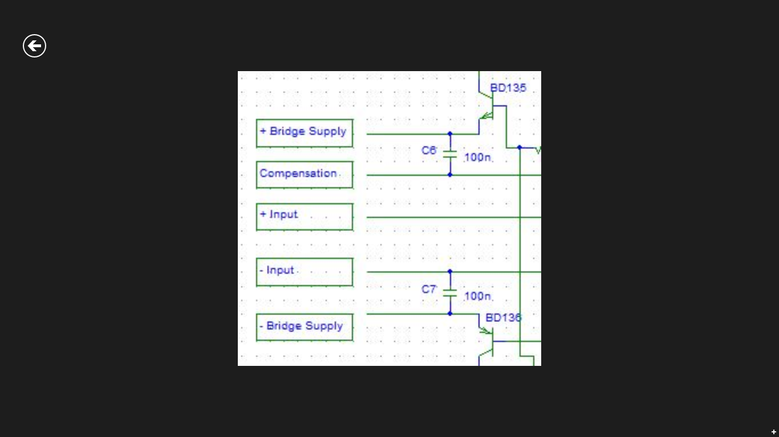

Figure 4.2.2.5: BD 135 and BD 136 transistor configuration.

After designing this circuit the next step was to build it on bread board and connect it to the full-bridge circuit configuration. It was then tested to make sure that it would operate as required. It was noticed that by varying variable resistor to balance Wheatstone bridge configuration, a full-bridge circuit configuration could be balanced and by varying bridge supply variable resistors the system could be made more sensible and responsible.

Labview software

## 5.1 Introduction

In this chapter the software aspect of the project will be discussed. At the start while the software was under development process, to prove a concept and to test the system for correct operation the multi-meter was used to avoid delay or held backs on the project progress.

LabView was chosen as the software development programme which would be used for the data acquisition and processing. It was developed by National Instruments and is a graphical programming language used to create programs in block diagrams. The G programming language is central to LabView. It’s allows the creation of visual instruments (VI’s). Which are software modules that acquire, process and display measurements in a similar fashion to conventional bench-top instruments.

Block Diagram

The block diagram contains most of the items that can be written in a conventional programming language. It contains loop structure such as for loop, while loop and case statements. It also contains event structures which execute on the occurrence of a particular event. Sequence structures are also available for applications in which the order of commands is important. Within this structure most of the features of a programming language can be added. Most mathematical and Boolean expressions can be evaluated, strings can be manipulated, files can be written or read from and signals can be created, manipulated and controlled. Some of the more complex tasks are performed using prewritten VI available in LabView libraries to make a life a bit easier for LabView programmer.

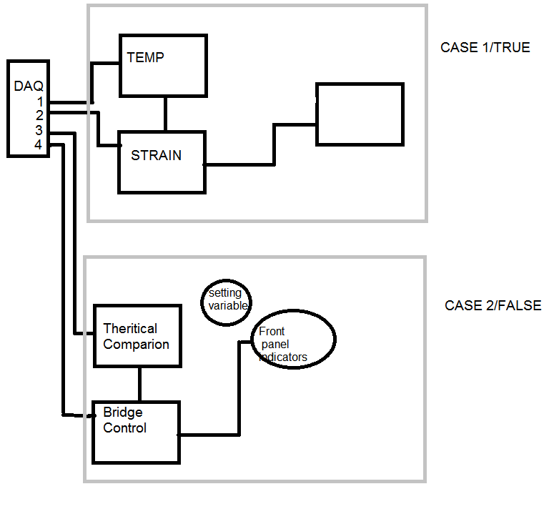

The block diagram above shows the software plan for the signal that are acquired from the DAQ USB 6008. This gives the structure of the code and allows for the overview of the necessary requirement to develop. Looking at case 2/false shows how to interface directly with the bridge supply on the amplifier and using the poterminoters VRI and VR2 to control the bridge supply and the zeroing of the strain when under no load

After the data acquisition is complete the data will be displayed through the LabVIEW. LabVIEW is a system-design platform and development environment for a visual programming language from National Instruments. LabVIEW is commonly used for data acquisition instrument control and industrial automation on a variety of platforms including Microsoft Window various versions of UNIX, Linux and Mac OS X. [8]

## 8.1 Graphical programming

## LabView interacts with the user through programs called VI’s virtual instruments. Each VI has three components: a block diagram, a front panel and a connector panel. The user of the program will interact with the “Front panel”, the front panel is where the data is presented through indicators, the user will interface with the program using control.

## This type of software development environment is a easily interaction between the programmer and the environment. The programmer can simply drag and drop the bock need to build a software programme.

The graphical approach also allows non-programmers to build programs by dragging and dropping virtual representations of lab equipment with which they are already familiar. The LabVIEW programming environment, with the included examples and documentation, makes it simple to create small applications

### 5.1.1 Front Panel

The user interface, or front panel, models itself on equipment which is found in electronic or automation laboratories with gauges, thermometers and digital displays being among the range of indicators. Slide controls, digital displays and manual entry boxes are among the controls that are available. Controls are used as input parameter to the procedures which perform the workings of the program. These procedures are written in the block diagram which contain all the background workings. Indicators show results from calculations performed within the block diagram

### 5.3 Wiring

Wiring the foil strain gauges from test speciment to the strain gauge amplifier was taken into consideration to help minimise the introduction of noise. Evan though the full-bridge configuration provides the highest sensitivity and because the full-bridge produces the highest output voltage, noise is a less significant factor in the measurments. There is still a posibility that measurments can be effected by the noise from electrical devices in the sorrounding area or other factors. Due to these factors it was decided to use a cable consising of a single twisted pair of tinned copper conductors screened overall in aluminised polyester tape with integral drain wire, as seen in Figure 4.5.1.1.

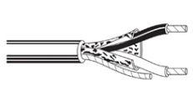

Figure 4.5.1.1: Single twisted pair shielded wire

The wire shielding was grounded to stop any possible noises interfering with the measurement. All eight foil strain gauges were grounded using common ground located on the ADC board.

### Part 6 DAQ

Transistor are used for T1 and T2 are NPN and PNP these are used in the circuit as pull up and pull down transistors which means they will provide a steady current to the resistive bridge.

The potentiometer of R2 10k is used to zero the stain with no load.

Capacitor decoupling the power supply

Zener Diodes, are temperature dependant and will keep the voltage rock soild D2, the D1 zener will also keep the voltage rock solid but as these have a range between 5.9 volts and 6.5volts the can be adjusted by connected to a 10k ohm pot this will be adjusted to set the voltage output of the resistive bridge supply when the bridges is without stress.

The output from this circuit will be converted in a digital signal by the NI USB -6008; this topic will be discussed in the next chapter.

Chapter 7 ADC converter

This ADC converter will allow the interaction between the analogy inputs of the amplifier and the temperature circuits to convert into a digital signal. This ADC converter is a Successive Approximation converter.

**7.1 ADC converter**

C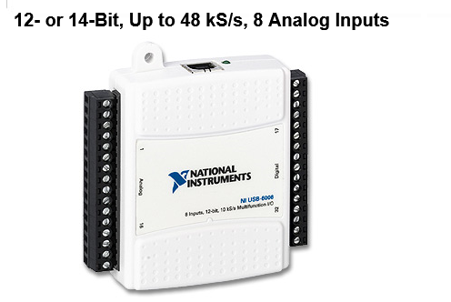

Figure 7.1 National Instruments USB-6008[8]

Uses the Successive approximation ADC

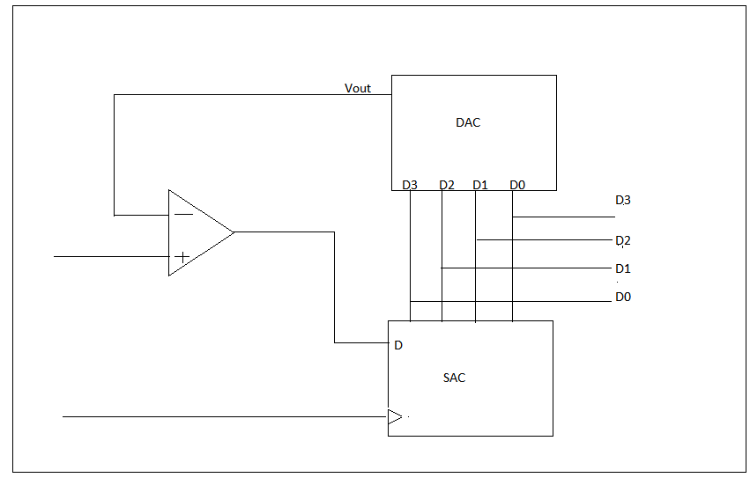

Figure 7.2 successive Approximation ADC

The successive approximation ADC uses a DAC to convert to a digital out. The advantage of this is that the conversion is very simple, but can take extra time compared to other ADC’s. The operation of this will be explained now.

If we take 3.5v input on the comparator (reference), the vout from the DAC will be compared starting with the MSB to the LSB.

Comparing the vout form the DAC to the reference, because the DAC is only a 4 bit the first comparison will set the MSB high and compare 1000, if 3.5v is greater than 23 = 8V the MSB will be set to one, in this case the MSB is set to 0. 0000

The next bit is sent high and compared to the comparator voltage input 0100. If 3.5v is greater than 22  = 4 v then set that bit high or else set low. In this comparison the set low, 0000

The next bit is set high and compared to the comparator voltage input 0010 which is 21 = 2v, if 3.5v is greater than 2v then set the bit high or else set it low, in this case its set high.

The next bit is set high and compared to the comparator voltage input 0011 which is 21+20 = 4v, if 3.5v is greater than 4v then set the bit high or else set it low, in this case its set high.

Analogy input of 3.5v is converted to digital 0011

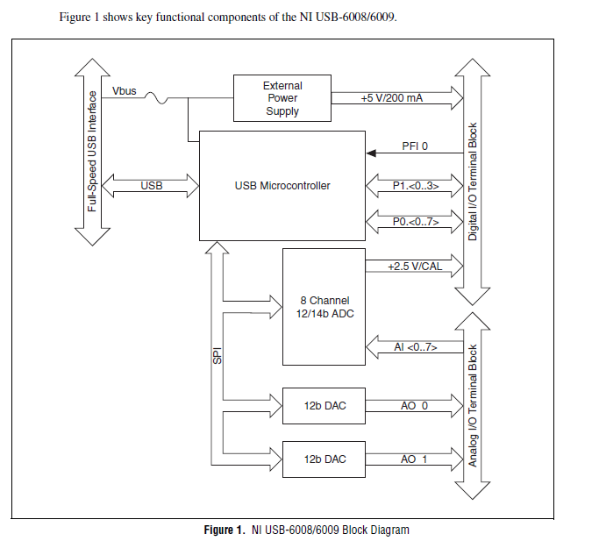

[7]

The advantage of using this ADC converter is that it will give access to more generic Laberies in Labview. Giving access to the ADC assistant.

Part Procedure

Introduction

Sourcing material

Appling the strain gauges to the steel

Connection strain gauge to the amplifier

Assembling the strain gauge amplifier

Connection to the DAQ

Power supplies

Creating a interface through LabView

# Results and Discussion

## 6.1 Introduction

The main purpose of the tests that were performed, was to detect how accurate are the measurement taken by the strain gauge system when comparing to ideal theoretical results.

As previously mentions a strain measurement can vary with temperature. To detect how accurate are the strain gauge system reading over varying temperature a specially designed test was conducted.

## 6.2 Theoretical Strain vs Weight

At the start the strain experienced by the bend aluminium rod at specific point when there is weight suspended at the end of test specimen was calculated, so that theoretical strain can be compared with the strain measured by the strain gauge system to determine how accurate the system is. To be able to calculate strain at specific point a Hooks Law equation described in the theoretical chapter 2.1 was used. A calculations were performed for two separate points on the test specimen, this will demonstrate that a strain experienced by the bend aluminium rod depends on the distance between anchor point and point there strain gauges are mounted.

A theoretical strain experienced by the bend aluminium rod when strain gauge systems are mounted 110mm and 230mm from anchor point were calculated, for when a weight suspended on the end of aluminium rod is increased from 0g to 1kg in steps of 100g. A strain calculations for system one and system two were graphed, to display visually how strain experienced by the test specimen varies with increasing weight. Figure 6.2.1 shows the Strain vs Weight theoretical graphs obtained for system one and system two.

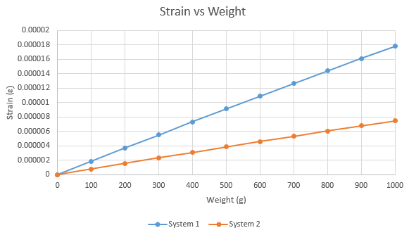

Figure 6.2.1: Strain vs Weight behaviour.

From the graph above it can be seen that a strain experienced by the bend aluminium rod increases linearly as the weight suspended on the end of test specimen is increased from 0g to 1kg in steps of 100g for both systems. From the graph above a conclusion can be drawn that a strain experienced by the bend aluminium rod at specific point increases linearly with increasing weight.

When comparing system one and system two results it can be noticed that strain experienced by the system two is more than twice less than strain experienced by system one, as weight suspended on the end of test specimen is increased from 0g to 1kg in steps of 100g. This is due to the fact that system one is mounted 110mm away from the anchor point and system two is mounted 230mm away from anchor point. This demonstrates that a strain experienced by the bend aluminium rod at specific point depends on the distance between anchor point and point where strain gauges are mounted. So a strain experienced by the bend aluminium rod is at its highest closer to anchor point and reduces as you move away from it.

## 6.3 Measured Strain vs Weight

After calculating strain experienced by the bend aluminium rod at two specific points in theory the next stage was to replicate that in practise.

With no weight suspended on the end of the test specimen, system was balanced reading 0mV, as the output voltage from the strain gauge system. The next step was to suspend weight on the end of the test specimen to determine, how a strain experienced by the bend aluminium rod varies with increasing force. The weight suspended on the end of the aluminium rod was increased from 0g to 1kg in steps of 100g. A strain measurements obtained by system one were recorded and graphed. Above steps were repeated several times to demonstrate how accurate is the system. Figure 6.3.1 shows the system one strain measurements recorded as a suspended weight at the end of test specimen was increased from 0g to 1kg in steps of 100g.

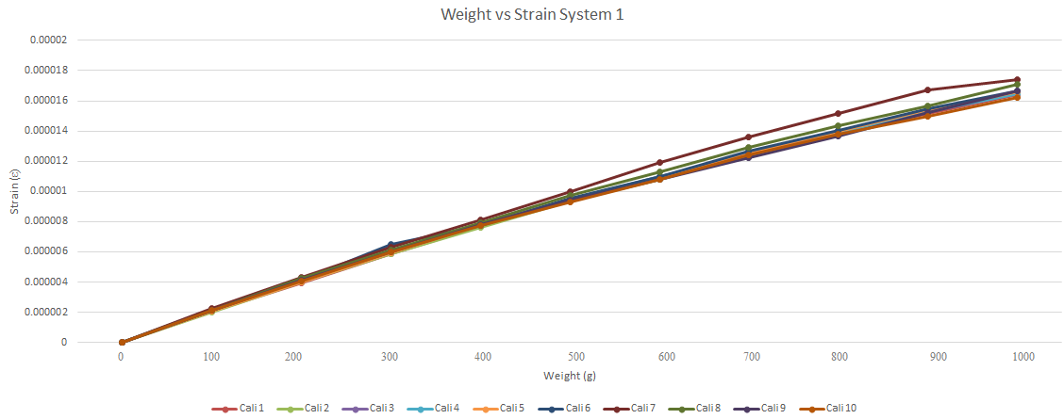

Figure 6.3.1: Strain vs Weight System one.

After recording and graphing system one strain measurement results. All of the above steps were repeated and a strain measurements obtained by system two were recorded and graphed. Figure 6.3.2 shows the system two strain measurements obtained as a suspended weight on the end of test specimen was increased from 0g to 1kg in steps of 100g.

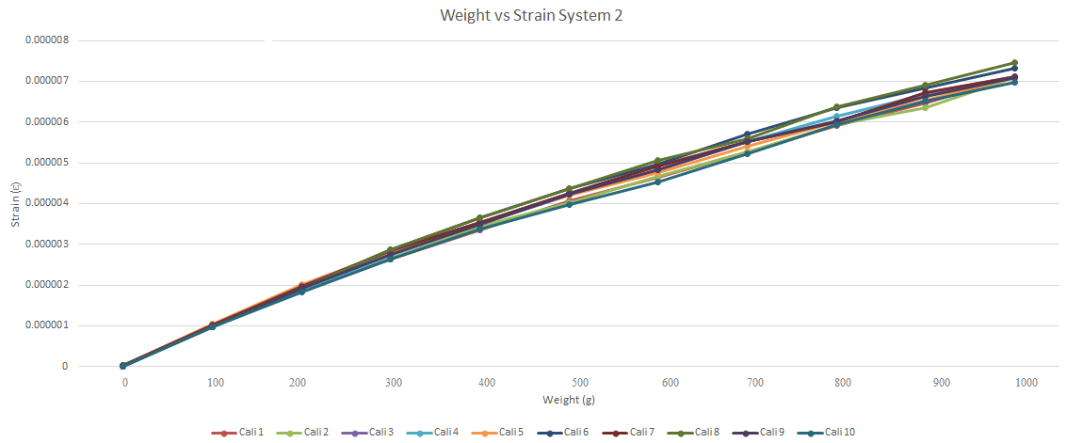

Figure 6.3.2: Strain vs Weight System two.

From the system one and system two response graphs above it can be seen that there is almost linear increase in strain as suspended weight on the end of the aluminium rod is increased from 0g to 1kg in steps of 100g. This is a strain response that would be expected as it was earlier demonstrated theoretically. Above graphs demonstrate that both systems are operating as it would be expected.

When comparing system one and system two results it can be noticed that strain experienced by the system two is more than twice less than strain experienced by system one as the weight suspended on the end of test specimen is increased from 0g to 1kg in steps of 100g. This is a result that would be expected as it has been proven theoretically before.

A theoretical strain results were compared with the measured strain results for both system one and system two to determine how accurate are the systems. After averaging both sets of results it was concluded that system one is 94% accurate and system two is 90% accurate. This is very good accuracy results for this strain gauge system as it’s almost impossible to achieve 100% accuracy as theoretical calculations are done for ideal conditions, which would be impossible to achieve in practise.

## 6.4 Measured Strain vs Temperature

After conducting some of the research it was found out that strain experienced by the bend aluminium rod at specific point can vary with temperature.

An experiment was conducted to detect variation in strain with change in temperature. It was decided to run this experiment overnight as there would be a variation in room temperate expected, which would result in decrease in aluminium surface temperature. At first system one was looked at. A weight of 1kg was suspended on the end of aluminium rod. An aluminium surface temperature and a strain measurement were taken every 10 min overnight and stored in a text file so that they can be analysed and graphed. Figure 6.4.1 below show the results that were obtained for system one.

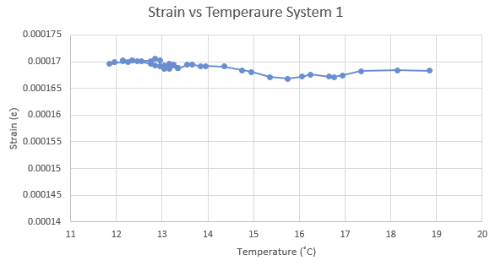Figure 6.4.1: Strain vs Temperature System one.

From the graph above it can be seen that aluminium surface temperature reduced from 18.8˚C to 11.8˚C overnight. It can be noticed that a strain varied by about 0.3µstrains over temperature. A formula below was used to determine how accurate the system response with variation in temperature.

$\frac{∆ε}{∆T}= \frac{dε}{dt}= \frac{0.3µ}{7}= ±0.04 µs/℃$

So from this a conclusion can be drawn that system one strain gauge measurements are $±0.04 µs$ accurate per degree Celsius change in temperature.

A procedure above was repeated for system two. Figure 6.4.2 below show the results that were obtained for system two.

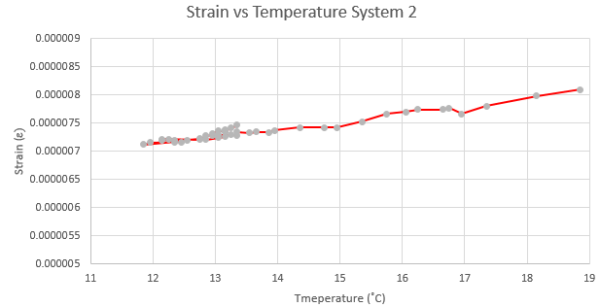

Figure 6.4.2: Strain vs Temperature System two

From the graph above it can be seen that as previously for system one an aluminium surface temperature reduced from 18.8˚C to 11.8˚C overnight. It can be noticed that there was larger variation in the strain measurements for system two when comparing to system one. There was about 1µstrain variation over temperature. A formula below was used to determine how accurate the system is with variation in temperature.

$\frac{∆ε}{∆T}= \frac{dε}{dt}= \frac{1µ}{7}= ±0.14 µs/℃$

So from this a conclusion can be drawn that system two strain gauge measurements are $±0.14 µs$ accurate per degree Celsius change in temperature.

## 6.5 Conclusion

After preforming a number of tests and comparing a strain gauge system measurement with ideal theoretical calculations, it can be concluded that system one is 94% accurate and system two is 90% accurate. These accuracy results are much better than expected. It is almost impossible to achieve 100% accuracy when comparing ideal theoretical results with practical results as theoretical calculations are done for ideal conditions which would be almost impossible to achieve in real world.

After observing variation in strain over temperature results, it can be concluded that system one is $±0.04 µs$ and system two is $±0.14 µs$ accurate per degree Celsius change in temperature. This higher variation in strain over temperature for system two could be due to the fact of lower micro strain readings making system response more sensible.

# Chapter 7

# Conclusions and Recommendations

The main aim of this project was to build a strain gauge system that will be able to measure a strain experienced by the bend aluminium rod and display all of the results in LabView in real time. By the time a project was completed two identical strain gauge systems were build, so it can be shown that strain experienced by the test specimen under force can vary depending on the distance between anchor point and a point where strain is measured. A results were displayed in LabView in real time as required by selecting a channel of a foil strain gauge system in action. All of the results taken by the strain gauge systems were compared to the theoretical calculations to determine how accurate the system is. From the results seen in measurement and result section of the report it can be seen that there is very close correlation between theoretical and measured results. The final result achieved was even better than expected.

Another feature that was added to the project was a temperature sensor to be able to determine how accurate the system response is over temperature. There are slight variation in strain over temperature, as it can be seen in measurement and result section of the report but this is a predicted behaviour.

Overall this project work was a great experienced as I gained greater understand of the strain gauge systems and their operation and at the end of the project we were able to show that measurements taken actually relate to theoretical strain calculations and are not just random values measured.

If this project to be continued there is some future work that can be done on this project. For this project a Wheatstone bridge configuration resistive circuit was used. But there are other resistive circuit available that will work with foil strain gauges, such as Chevron Bridge and Four-wire Ohm bridge configurations. It be good idea to look at these configuration in more detail, so that Wheatstone bridge configuration performance can be compared with the other resistive bridges in practise, to determine which configuration is best and most accurate.

As part of this project it was decided to use a full-bridge Wheatstone circuit configuration. It is a good idea to look into quarter-bridge and half-bridge configurations in more detail and perform all of the test done for full-bridge configuration on them too, to determine how accurate are each of the bridge configuration practically.

Two foil strain gauge systems were placed on the test specimen to show that strain experienced by the bend aluminium rod depends on the distance from anchor point to point where strain is measured. It be good idea to place more strain gauge system or move around existing ones on the test specimen, to show in more detail a correlation that there is between strain and the distance from the anchor point to the specific point where strain is measured.

A thermistor was used to measure temperature of aluminium rod but thermocouples can also be used to measure temperature. It be good idea to replace a thermistor with thermocouple to see if there is variation in response rate and accuracy when compared to thermistor.

At the end of the project only a strain from one strain gauge system was displayed in LabView in real time at ones by selecting system one or system two channel. It be good idea to conduct more research to find out how a strain measurements from two foil strain gauges systems can be read into LabView at a same time and displayed in real time on one graph.

0

# References

[] <http://www.jor.se/measurement/Kyowa/Kyowa-PDF/whats.pdf>

[2] <http://www.sensorland.com/HistPage003.html>

[3] <http://www.sensorland.com/HistPage003.html>

[4] <http://www.pcm-uk.com/straingauge-whatisastraingauge.html>

[5] <http://en.wikipedia.org/wiki/Strain_gauge>

[6] <http://www.ni.com/white-paper/3642/en/>

[7] <http://en.wikipedia.org/wiki/Young%27s_modulus>

[8] <http://www.engineeringtoolbox.com/young-modulus-d_417.html>

[9] <http://www.engineersedge.com/beam_bending/beam_bending9.htm>

[10] <http://en.wikipedia.org/wiki/Section_modulus>

[11] <http://www.technologystudent.com/elec1/resist2.htm>

[12] <http://docs-europe.electrocomponents.com/webdocs/001b/0900766b8001b962.pdf>

[13] <http://en.wikipedia.org/wiki/Strain_gauge>.

[14] <http://www.farnell.com/datasheets/69441.pdf>

[15] <http://en.wikipedia.org/wiki/Strain_gauge>.

[16] <http://en.wikipedia.org/wiki/Strain_gauge>

[17] <http://www.princeton.edu/~cavalab/tutorials/public/Thermocouples.pdf>

[18] <http://web.deu.edu.tr/mechatronics/TUR/strain_gauge.htm>

[19] <http://web.deu.edu.tr/mechatronics/TUR/strain_gauge.htm>

[20] The Art of Electronics Second Edition, by Paul Horowitz and Winfield Hill

[21] <http://books.google.ie/books?id=Ky8QH02d7zkC&pg=PA22&lpg=PA22&dq=advantages+and+disadvantages+of+cyanoacrylate&source=bl&ots=6NIhXx-PTY&sig=9Qi4aB7NrFBwfeS0HaOp5mb3GyU&hl=en&sa=X&ei=ED-CUaHwKqGR7AbI-IC4CQ&ved=0CEQQ6AEwBA%23v=onepage&q=advantages%20and%20disadvantages%20of%20cyanoacrylate&f=false#v=snippet&q=advantages%20and%20disadvantages%20of%20cyanoacrylate&f=false>

[22] <http://docs-europe.electrocomponents.com/webdocs/001b/0900766b8001b962.pdf>

[23] <http://docs-europe.electrocomponents.com/webdocs/001b/0900766b8001b962.pdf>.

[24] <http://docs-europe.electrocomponents.com/webdocs/001b/0900766b8001b962.pdf>

[25] <http://www.analog.com/static/imported-files/data_sheets/AD7190.pdf>

[26] <http://www.analog.com/static/imported-files/user_guides/UG-222.pdf>

[27] <http://zone.ni.com/reference/en-XX/help/371361H-01/lvinstio/visa_usb_control_in/>

[28] <http://zone.ni.com/reference/en-XX/help/371361H-01/lvinstio/conv_strain_read/>

[29] <http://zone.ni.com/reference/en-XX/help/371361H-01/lvinstio/conv_thermis_read/>

Chapter 9 Bibliography

[1],Matthew Duff and Joseph Towey. (2014). *Two Ways to Measure Temperature Using Thermocouples Feature Simplicity, Accuracy, and Flexibility.* Available: [http://www.analog.com/static/imported-files/data_sheets/AD8494_8495_8496_8497.pdf. Last accessed 13/10/2014](http://www.analog.com/static/imported-files/data_sheets/AD8494_8495_8496_8497.pdf.%20Last%20accessed%2013/10/2014).

[2]John. (2011). *Strain Gauge.* Available: http://www.instrumentationtoday.com/strain-gauge/2011/08/. Last accessed 22/10/14.

[3] National Instruments. ( 2011). How Is Temperature Affecting Your Strain Measurement Accuracy?. *White Papers* . 1 (2), 5.

[4] National Instruments . (2014). USER GUIDE AND SPECIFICATIONS . *NI USB-6008/6009*. 1 (Specifications), 30.

[5] Analog Devices. (2014). Type J Thermocouple Amplifier with Cold Junction Compensation. *Type J Thermocouple Amplifier with Cold Junction Compensation*. 1 (1), 5.

[6] Radionics. (2014). *24 pin DIL strain gauge amplifier.* Available: http://ie.rs-online.com/web/p/strain-gauge-accessories/0846171/. Last accessed 22/10/14.

[7] National Instruments. (2011). USER GUIDE AND SPECIFICATIONS. *NI USB-6008/6009*. 1 (Figure 1), 30.

[8] wikipedia. (2014). *LabVIEW.* Available: http://en.wikipedia.org/wiki/LabVIEW. Last accessed 2014.

**Literary References:**

Thomas L Floyd (2001). *Electronics Fundamentals*. 5th ed. New Jersey: Prentice Hall. 1100.

Charles Platt (2011). *Make: Electronic* . Canada: O'Reilly. 335.

# Appendix A

# Appendix B

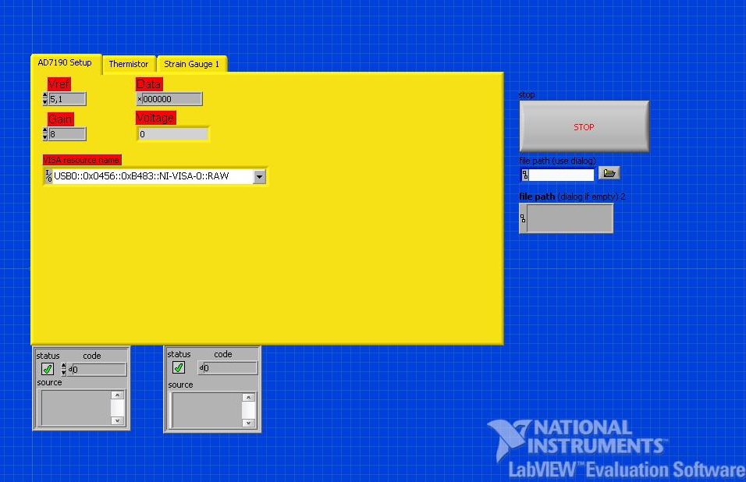

Figure 2.1: AD7190 front panel.

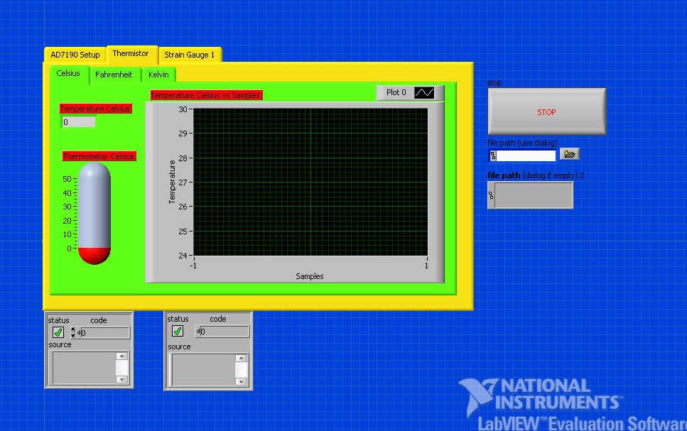

Figure 2.2: Thermistor front panel.

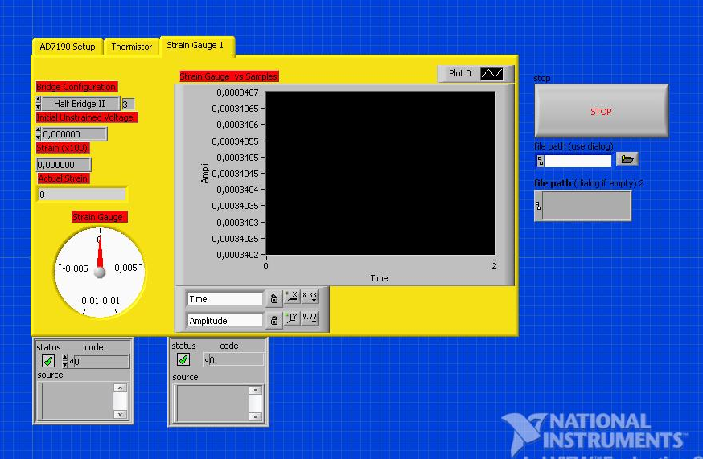

Figure 2.3: Strain gauge front panel.

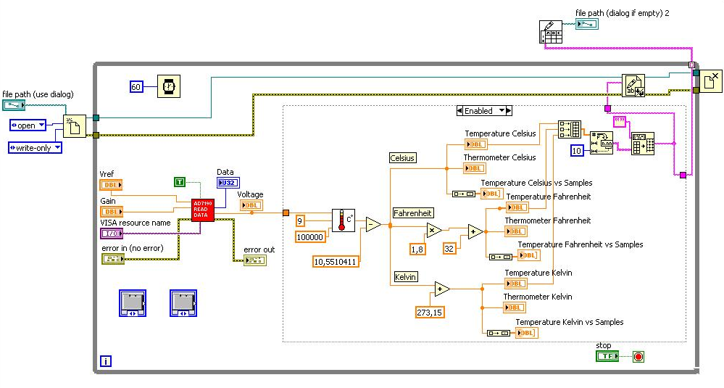

Figure 2.4: Thermistor block diagram.

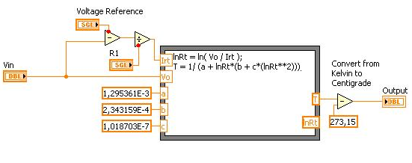

Figure 2.5: Converting voltage into temperature $℃$ block diagram.

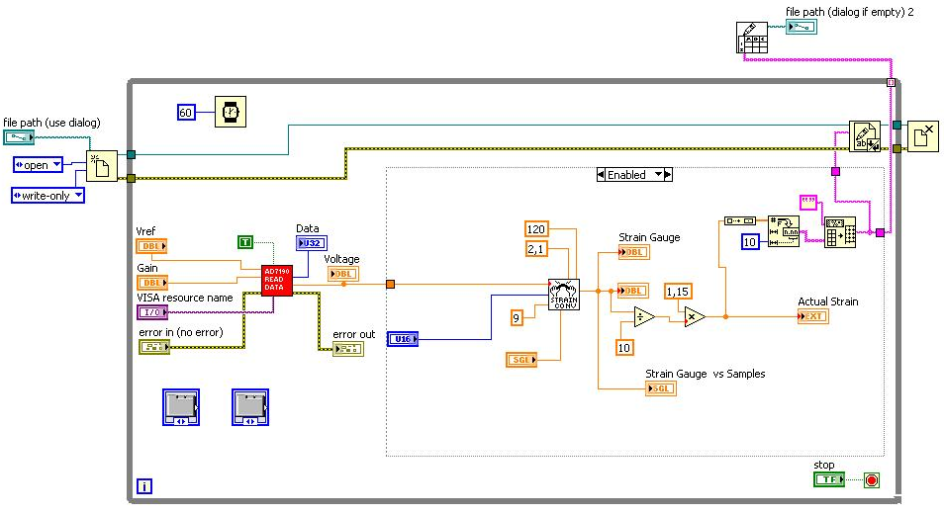

Figure 2.6: Strain Gauge block diagram.

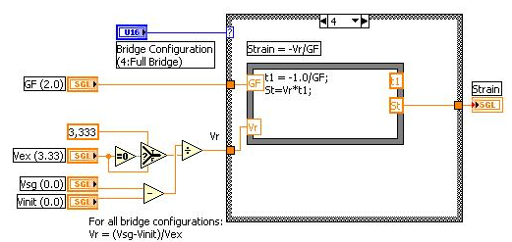

Figure 2.7: Converting voltage into strain block diagram.

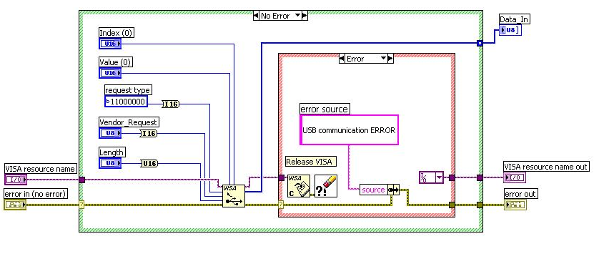

Figure 2.8: SPI/USB Interface block diagram.

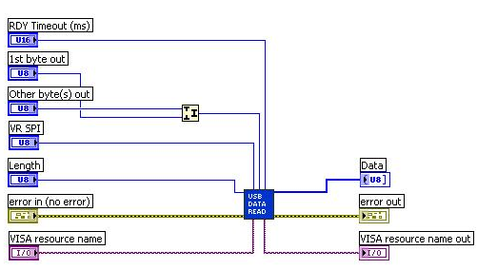

Figure 2.9: SPI read block diagram.

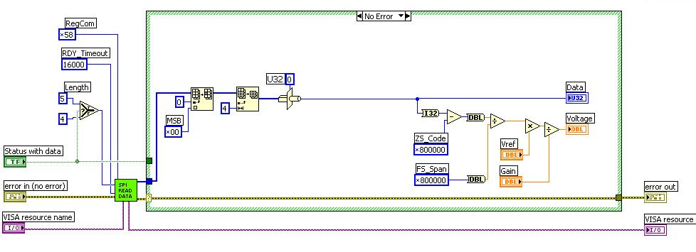

Figure 2.10: Date read block diagram.

# Appendix C

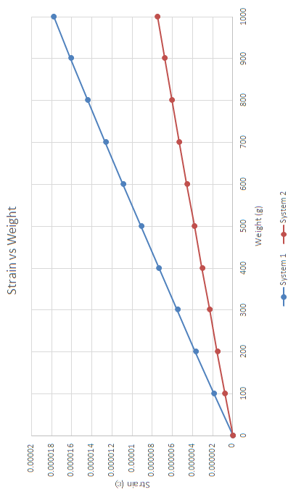

Figure 3.1: Theoretical Strain vs Temperature system one and two.

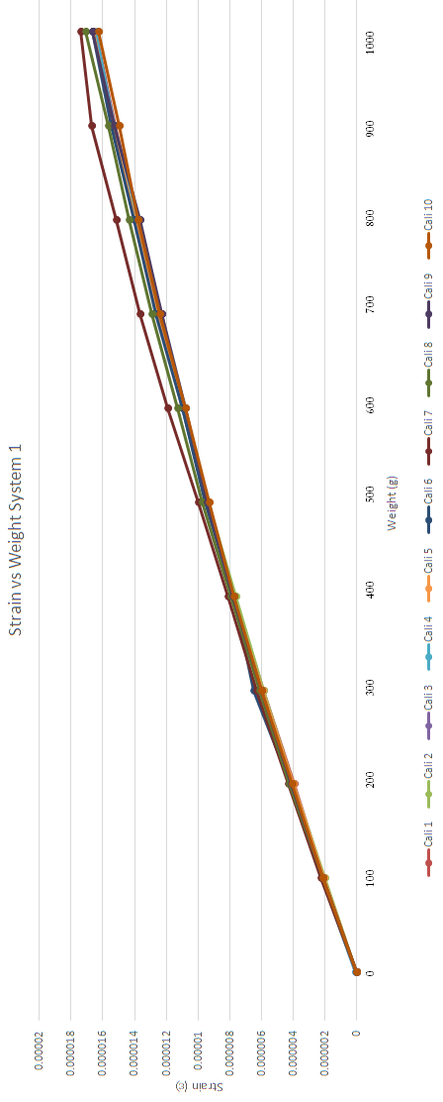

Figure 3.2: Strain vs Temperature system one.

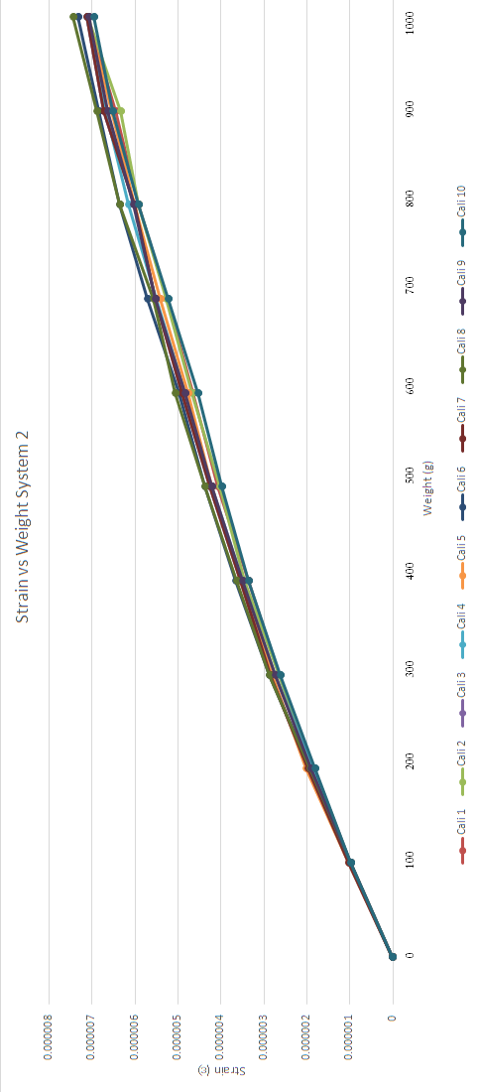

Figure 3.3: Strain vs Temperature system one.

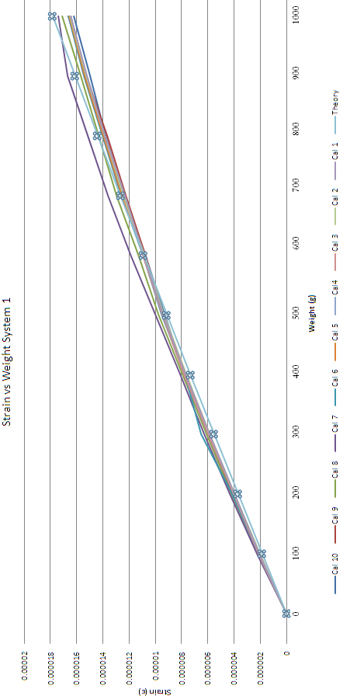

Figure 3.4: Strain in theory vs practise system one.

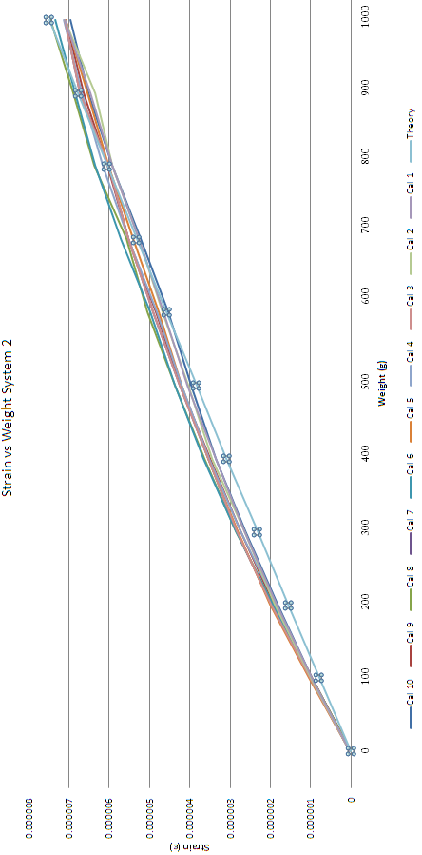

Figure 3.5: Strain in theory vs practise system two.

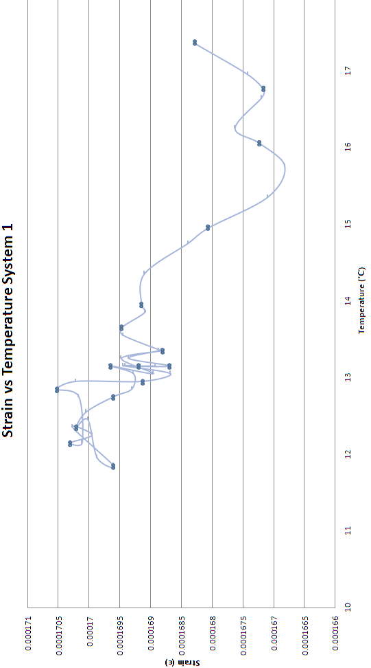

Figure 3.6: Strain vs Temperature system one.

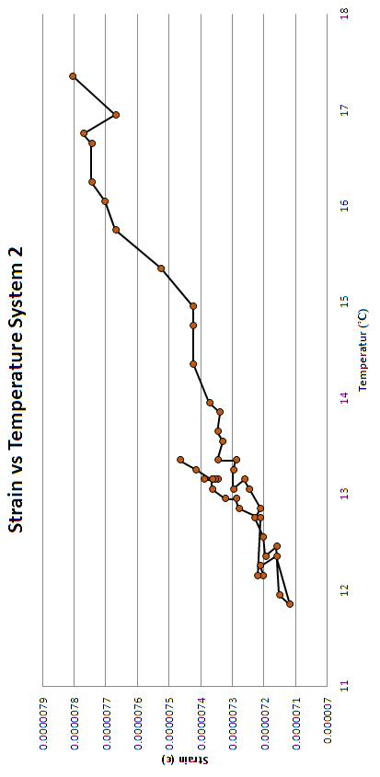

Figure 3.7: Strain vs Temperature system two.

# Appendix D

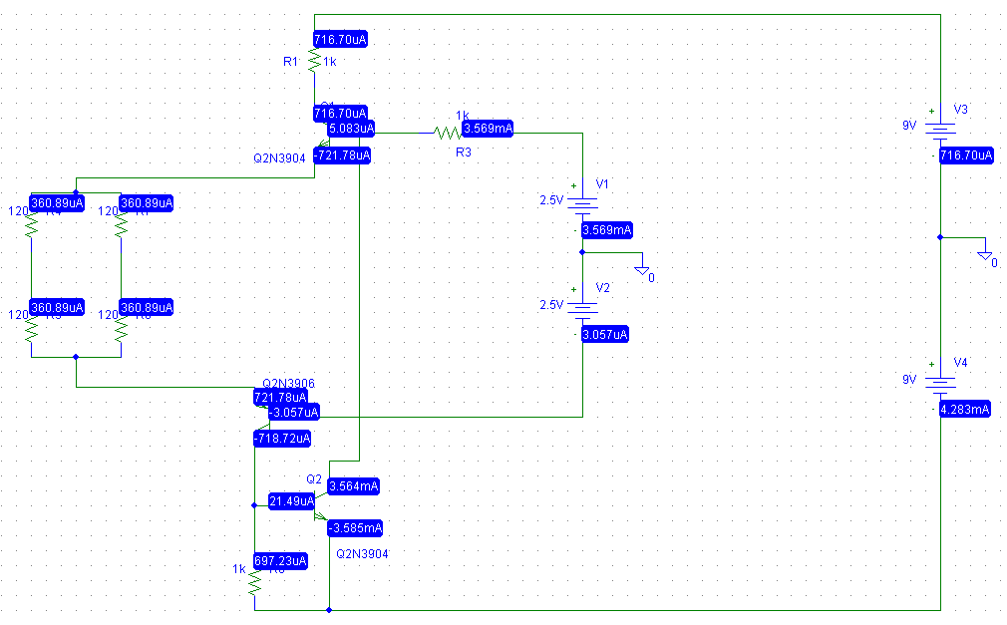

Figure 4.1: Current modelling for Wheatstone bridge configuration.

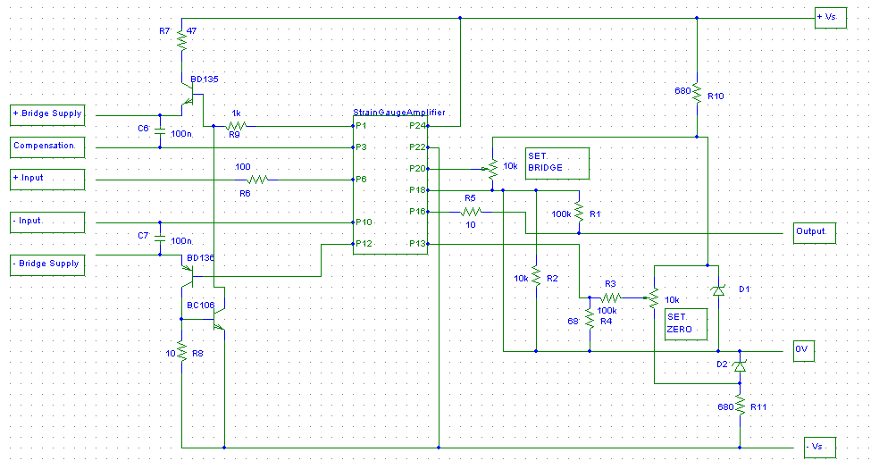

Figure 4.2: Amplifier circuit schematic in PSpice.